Patricia Hogan & Chris Kirk TLAC Conference Grant Program Application
Winter 2012

Grant Goal: To increase faculty access to conferences/workshops that focus on collegiate teaching. We are requesting grant money of $800 each ($1600 total) to attend and present (accepted 90 minute workshop) at the International Improving University Teaching Conference in Innsbruck, Austria , July 24-27, 2012.

Title of Presentation: WIX AS A PLATFORM FOR SHOWCASING LEARNER-CENTERED COURSES AND OUTCOMES ASSESSMENT

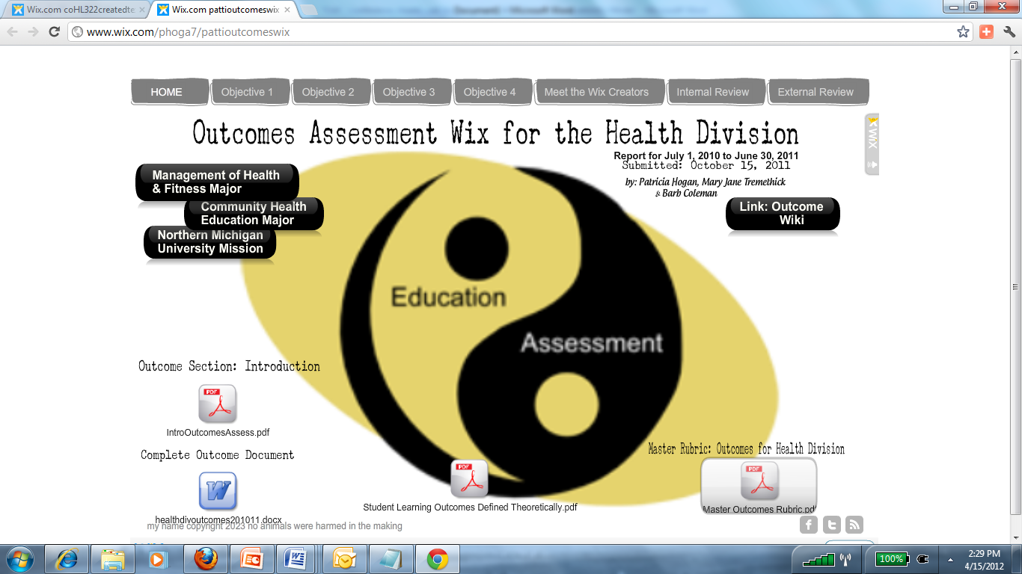

Introduction:

Patricia Hogan and Chris Kirk, both of the HPER Department, are applying for a grant for $800 each to attend the International Improving University Teaching (IUT) conference in Innsbruck, Austria in July 2012 (http://www.iutconference.com/about.htm). We have been accepted to present a 90 minute workshop using Wix, a free Flash-based website building platform which provides a simple and fast way to create web design content and creative endeavors for learner-centered courses and outcomes assessment, to promote active learning and new ways to display outcomes assessment. The presenters have used the Wix platform for incorporating and displaying teacher-student co-created courses and co-created texts (e.g., see http://www.wix.com/phoga7/cohl322createdtextf11 and especially go to co-created course tab ) as well as for portraying student work demonstrating the meeting of university mission-central outcomes (see http://www.wix.com/phoga7/pattioutcomeswix ) - truly assessment outside the box. We shall present evidence that the Wix (integrated with active learning models such as project-based learning) provides a relevant and effective way to challenge students relative to the 3 C’s of 21st Learning: Creativity, Collaboration, and Communication (Friedman & Mandelbaum, 2011) to solve real world problems.

The following identifies our 1) eligibility for these awards and 2)contains the application materials.

- Eligibility for Awards based on the Criteria for Selection:

Awards will be made by the TLAC based on:

- We are both full time faculty in the HPERD Department at NMU., Kirk is in Athletic Training and Hogan is in Management of Health & Fitness
- Demonstrated interest in teaching and pedagogical issues, including scholarship of teaching: Hogan has won a number of awards for innovation in teaching and learning (see http://en.wikipedia.org/wiki/Patricia_Hogan ) and Hogan & Kirk have attended Problem Based Learning workshop together, and have authored presentations and publications on active teaching and learning (see vitae). In addition, Kirk has attended the active learning workshop presented at NMU.
- Consideration will be given to new faculty members seeking ideas for immediate improvement of their teaching: Neither Kirk nor Hogan is considered a “new” faculty member, but we are constantly collaborating to promote improvement of our teaching in line with 21st century skills needed by students.
- Consideration will be given to senior faculty members seeking ideas for updating or remodeling some aspect of their pedagogy: Hogan is definitely a senior faculty member and is moving into new areas of high tech active learning pedagogy… actually, into andragogy and heutagogy (see slides below) as well as into 21st century education models. Kirk is also addressing these issues. See the following slides for our focus on new active learning models, especially on those using new technology; we want to do new things in new ways:

- Consideration will be given to faculty members who will share conference information with the university community about what constitutes excellent in teaching and learning. Both of us are willing to give the 90 minute workshop at NMU at the discretion of the Teaching & Learning Advisory Council.

- Application Materials:
- Essay: Hogan and Kirk have been accepted (see attached) to present a 90 minute workshop entitled: WIX AS A PLATFORM FOR SHOWCASING LEARNER-CENTERED COURSES AND OUTCOMES ASSESSMENT at the International Improving University Teaching (IUT) conference (see http://www.iutconference.com/about.html) in Innsbruck, Austria in July 24-27, 2012.

An outline of the conference workshop follows:
ABSTRACT: A WIX WORKSHOP

Wix, a free Flash-based website building platform, provides a simple and fast way to create web design content and creative endeavors for learner-centered courses and outcomes assessment. The presenters have used the Wix platform for incorporating and displaying teacher-student co-created courses and co-created texts (see http://www.wix.com/phoga7/cohl322createdtextf11 ) as well as for portraying student work demonstrating the meeting of university mission-central outcomes (see http://www.wix.com/phoga7/pattioutcomeswix ) - truly assessment outside the box. Workshop leaders will present evidence that the Wix (integrated with active learning models such as project-based learning) provides a relevant and effective way to challenge students relative to the 3 C’s of 21st Learning: Creativity, Collaboration, and Communication (Friedman & Mandelbaum, 2011) to solve real world problems. In this workshop, participants, using their own laptop computers or mobile devices, will develop their own course Wix and/or outcomes assessment Wix and will plan 21st Century active learning strategies to include students as co-creators of course content whose work is published on the Wix and whose work can be shown via a Wix to demonstrate university mission-central outcomes.

GOALS AND LEARNING OUTCOMES OF THE WIX WORKSHOP

- Introduce participants to our work integrating active learning (problem-based learning; project-based learning) with a Wix platform (please see an example at http://www.wix.com/phoga7/cohl322createdtextf11 ), discuss evidence indicating the work is relevant and effective in meeting university mission-central outcomes, and discuss how this work reflects new educational models (i.e., andragogy and heutagogy vs. pedagogy; constructivism and connectivism vs. behaviorism; the 3 C’s of Education) required for 21st Learning.
- Engage participants in developing their own Wix pages for a class they teach; have participants engage in group work to discuss active learning projects they could engage their students in that reflect creative and collaborative work designed to address real world problems. Teach them how to upload these projects to the course Wix.
- Introduce participants to our work using a Wix as a platform to display outcomes assessment data including actual demonstrations of mission-central student work (see http://www.wix.com/phoga7/pattioutcomeswix). Discuss evaluative feedback from internal and external reviewers about the efficacy of the outcomes assessment Wix.
- Engage participants in developing their own outcomes assessment Wix. Engage a discussion about which student work could be portrayed on the Wix, and how the Wix easily allows for both internal and external reviewers.
- Discuss how to go forward to implement workshop ideas and offer our assistance.

Anticipated Expenses:

Airplane tkts | Other transport | Lodging | Meals | Conf Fees | Total per person
Hogan  $2000 | Hogan  200 | 5 nights at $150= $750 | 6 days at 35 =  $210 | $545 | $3705
Kirk  $200 | Kirk  200 | 5 nights at $150= $750 | 6 days at 35 =  $210 | $545 | $3705

- Your curriculum vita: Please see attached for our curricula vitae.
- Acceptance Email… Please see attached.
- Submit application materials to TLAC@nmu.edu by the appropriate deadline. We did.

