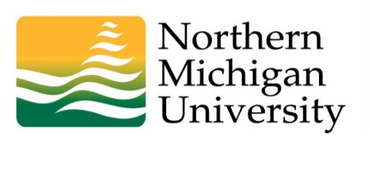

Accreditation Update to
Academic Senate

April 14, 2015
Kim Barron, Director of Accreditation and Assessment

- Review Strategy Forum meeting (April 22 – 24)
  - Purpose of meeting
  - 2015 planning group and attendees
  - Topics to be addressed
  - Projects to launch as a result of the meeting

- Accreditation Steering Committee established
  - Current committee members
  - Policy for choosing an Action project
  - Policy for committee membership

- Status of current Action Projects
  - Launch Action Project on April 15
  - Strategy Forum will result in at least one more Action Project
  - A Category 1: Helping Students Learn Action Project will need to be launched by September 30 (submit recommendations)

- Faculty input in accreditation activities

- Site visit (Quality Checkup) will take place in 2016-17

