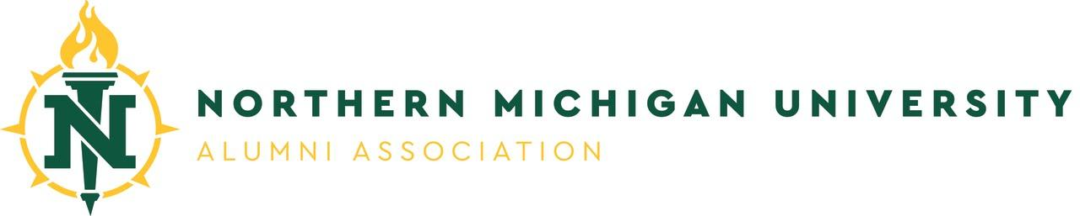
The Alumni Legacy Scholarship

The Alumni Legacy Scholarship is offered exclusively to students whose parent or grandparent is a Northern Michigan University alumni and reside in the state of Michigan. The NMU Alumni Association awards up to ten $1,000 Legacy Scholarships annually. Students who receive this scholarship may re-apply.

Application Instructions:

- The scholarship application window for the 2023-2024 academic year is open from Monday, January 23 through February 20, 2023.
- Students can apply by logging in to MyNMU and finding the Financial Aid – Donor-Funded Scholarships link on the left-hand side under Student Services. New students can find the link on the Admitted to NMU tab in MyNMU.

In order to qualify for this award, students must meet the following criteria:

- Must be the child or grandchild of a Northern Michigan University graduate.
- Must be a Michigan resident attending NMU, having earned at least 60 credits (junior status).
- Must be a continuous, full-time student enrolled in at least 12 credit hours per semester for the duration of the award.
- Must complete the Alumni Legacy Certification Form.
- Must complete a Personal Statement paper that addresses the following:

- Please describe your extracurricular involvement (school, community and/or spiritual organizations) during the past three years;
- For your parent or grandparent who is an alumni, what do they describe to you as their best memory of their NMU experience?
- Why did your parent/grandparent choose to attend NMU?
- Why did you choose to attend NMU?
- Any other information you would like to share with the scholarship committee.

Alumni Legacy Certification Form

This form must be completed by the NMU alumni parent/grandparent residing in the State of Michigan whose children/grandchildren are applying for the NMU Alumni Legacy Scholarship.

I, _____________________________________, certify that ____________________________________,
(Alumnus/Alumna’s full legal name) (Student’s name)

___________________________________________ is my child / grandchild (circle one).
(Student’s NMU IN)

I graduated from Northern Michigan University in _____________ with a ___________________degree.
(Year) (Type of degree)

Signed ________________________________________________________________________

Date ________________________________________________________________________

Last four digits of Social Security Number (for ID verification) ________________________

Name used when enrolled at NMU, if different from signature ________________________

Address __________________________________________________________________

Telephone __________________________________________________________________

Email __________________________________________________________________

Students: Upload this completed form to the Scholarship Application website, fax to NMU Alumni relations at 906-227-3424 or deliver to 1102 Northern Center, 1401 Presque Isle Avenue, Marquette, MI 49855. Please call 877-472-3668 with any questions.

