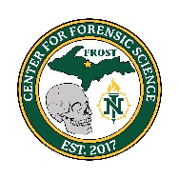

NMU Center for Forensic Science
Postmortem Imagery Workshop

Instructor: Dr. Jane Harris, Director, NMU Center for Forensic Science

This three-day course provides instruction on craniofacial anatomy, the ways in which the face can be affected by death-related changes, decomposition, and other postmortem conditions, as well as drawing skills needed to render a high-quality postmortem facial image. Upon completion of this course, the participants will be able to:
- Decide when a postmortem image is possible/appropriate based on the decedent’s condition
- Describe postmortem changes that affect the appearance of the human face
- Draw naturalistic representations of human faces

When: July 8, 9, 10, 2026
Time: 8 a.m. – 5 p.m.
Location:
Jacobetti Complex Rm. 502
2296 Sugarloaf Ave.
Marquette, MI 49855 &
Cost: Member $75 Non-Member $225
To Register: CVENT
Registration Deadline: July 1, 2025

MCOLES Credit available for Michigan Law Enforcement Officers
This class qualifies for continuing education credits.
Please contact Carley Leanes at (906) 227-1144 with any questions.

