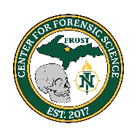

NMU Center for Forensic Science
Presents:
Human vs Nonhuman Bone Identification

Instructors: Dr. Malorie Albee, Assistant Professor, Sociology & Anthropology

During this 1-day course participants will gain a working knowledge of normal human skeletal anatomy and learn the basics of human vs nonhuman bone comparisons.
Participants will examine human skeletons from the Center for Forensic Science Donated Skeletal Collection and discuss both normal skeletal anatomy and common variations.
Topics Covered: Overview of the human skeleton, basic bone biology, anatomical terminology, anatomy of the skull, postcranial anatomy, common anatomical variations, human vs nonhuman bone.

May 18, 2026
9:00 a.m. – 5:00 p.m.
Location: Jacobetti Complex Rm. 502
2296 Sugarloaf Ave.
Marquette, MI 49855
Cost: Member $50
Non-Member $150
To Register: CVENT
Registration Deadline: May 1, 2026

MCOLES Credit for Michigan Law Enforcement Officers
This class qualifies for continuing education credits.

