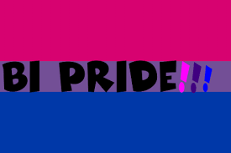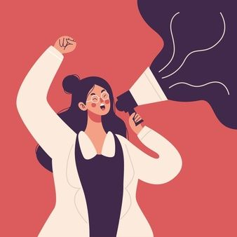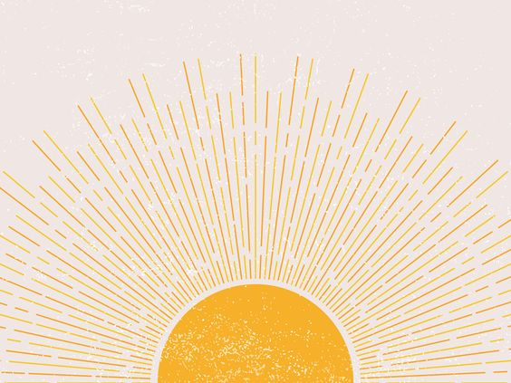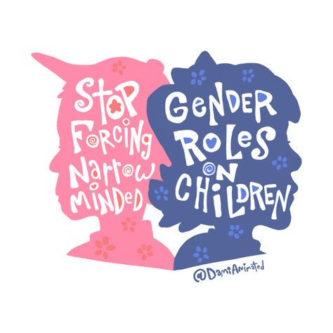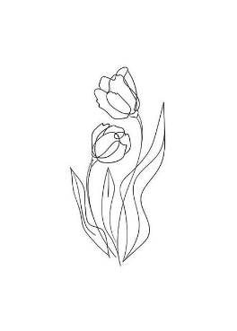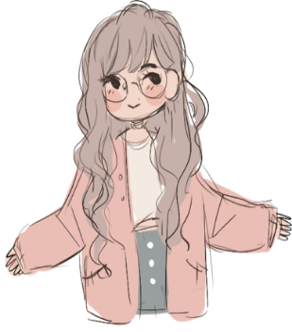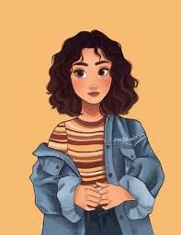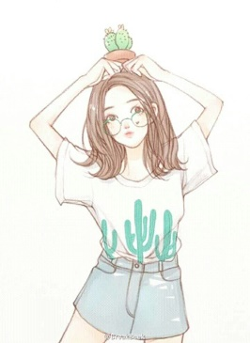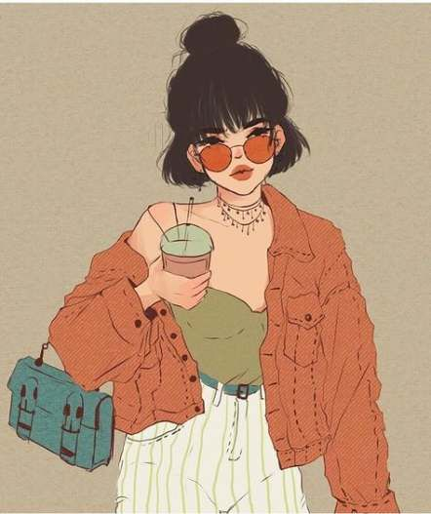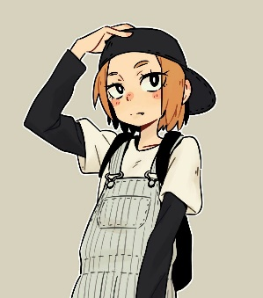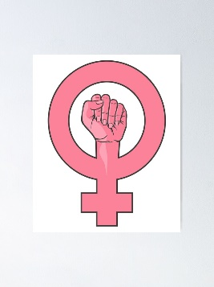

G E N D E R I D E N I T Y

I’M EDUCATED ENOUGH TO BELIEVE WE SHOULD

**EVERCHANGING**

STRONG & INDEPENDENT

BISEXUAL AND PROUD

THURSDAY:

FRIDAY:

WEDNESDAY:

TUESDAY:

MONDAY:

I AM A STRONG WOMAN

MY PRONOUNS ARE SHE/HER, THANKS FOR ASKING

I LIKE TO THINK OF MYSELF AS RAYS OF SUNLIGHT