Student MiLogin Instructions
https://milogin.michigan.gov/eai/login/authenticate?PolicyId=urn:ibm:security:authentication:asf:basicldapuser&Target=https%3A%2F%2Fmiloginci.michigan.gov%2Foidc%2Fendpoint%2Fdefault%2Fauthorize%3FqsId%3D7619736f-a3f2-48fb-a5e8-2b97dee2f46d%26client_id%3D28d60358-8345-4827-9a4d-de796b4159c7
If this link doesn’t work, simply Google = State of Michigan MiLogin
***This is the same login page you may have used in the past to renew your car tabs.
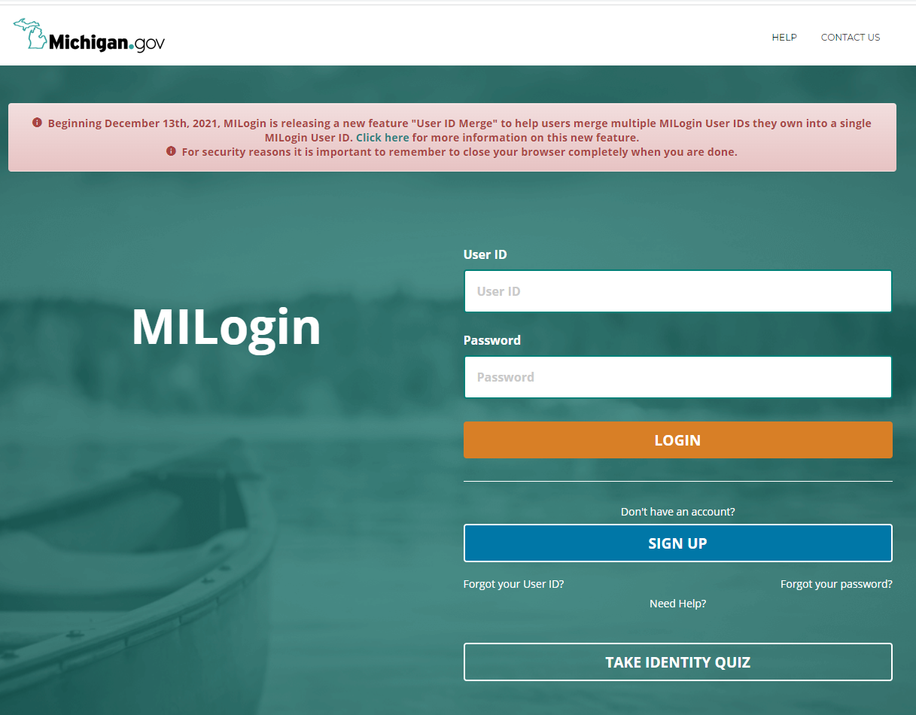
- Either sign up or sign in if you’ve created an account in the past. It is ok to create a new account if you’d like to keep your personal life and school life separate – you simply will need a different email address than your personal account.
- Complete the Profile Information
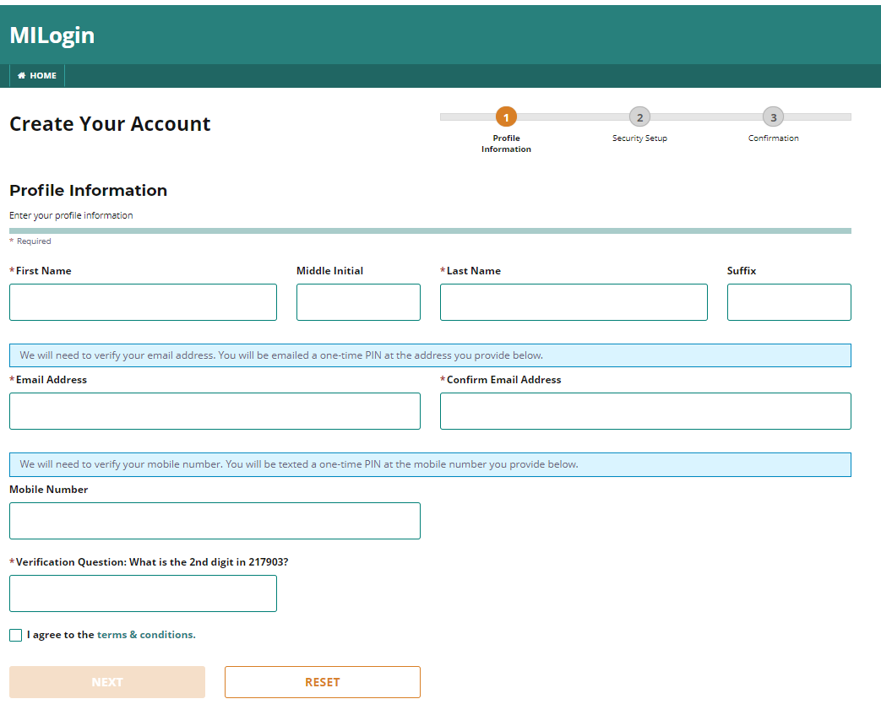
Next Create a username and password
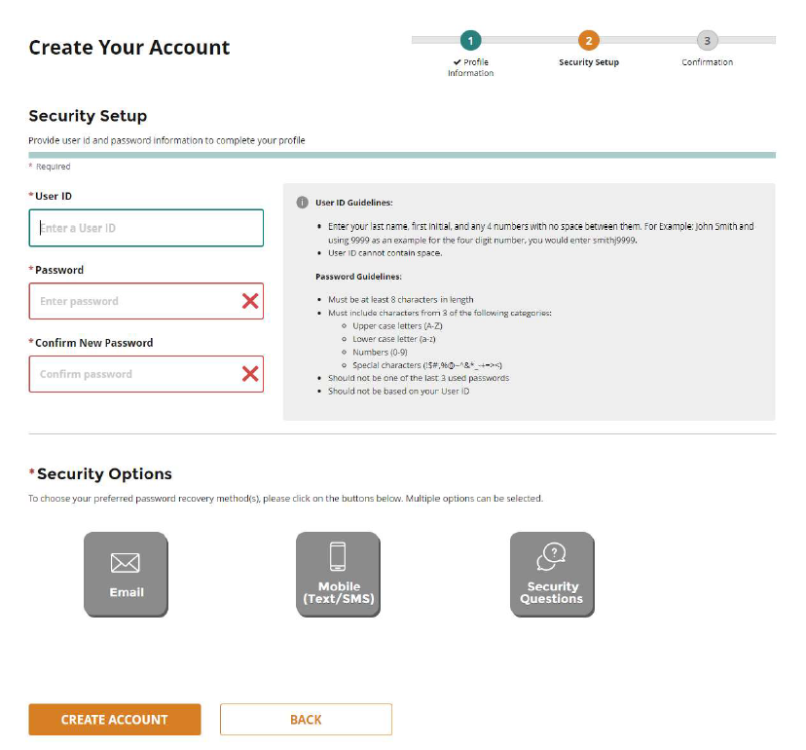

You in the system, you’ll need to request access to the Future Faculty Fellowship Program
