Application process
Sign in or create an account for the FFF Program (instructions) on separate attachment.
Click on the application under ‘My opportunities’ on the right hand side of the page.
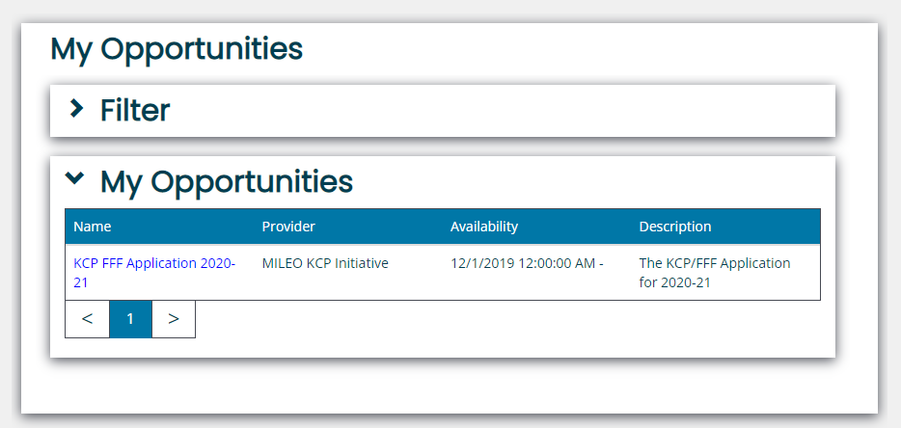
Click on agree
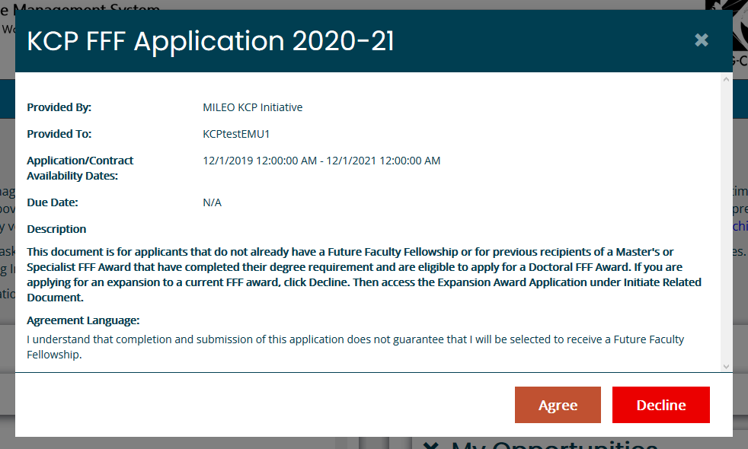

Complete Phase 1 – Eligibility Section (far left of page)
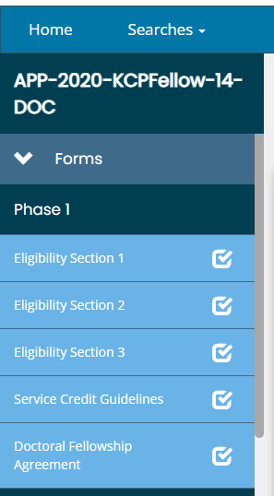
Complete the required questions in Phase 1 (section 1). As you complete each Eligibility Section, a new section will pop up.

If you answer any questions wrong, a red error message will pop up. If you answer all questions correctly, the system will open up Phase 2 for your competition.
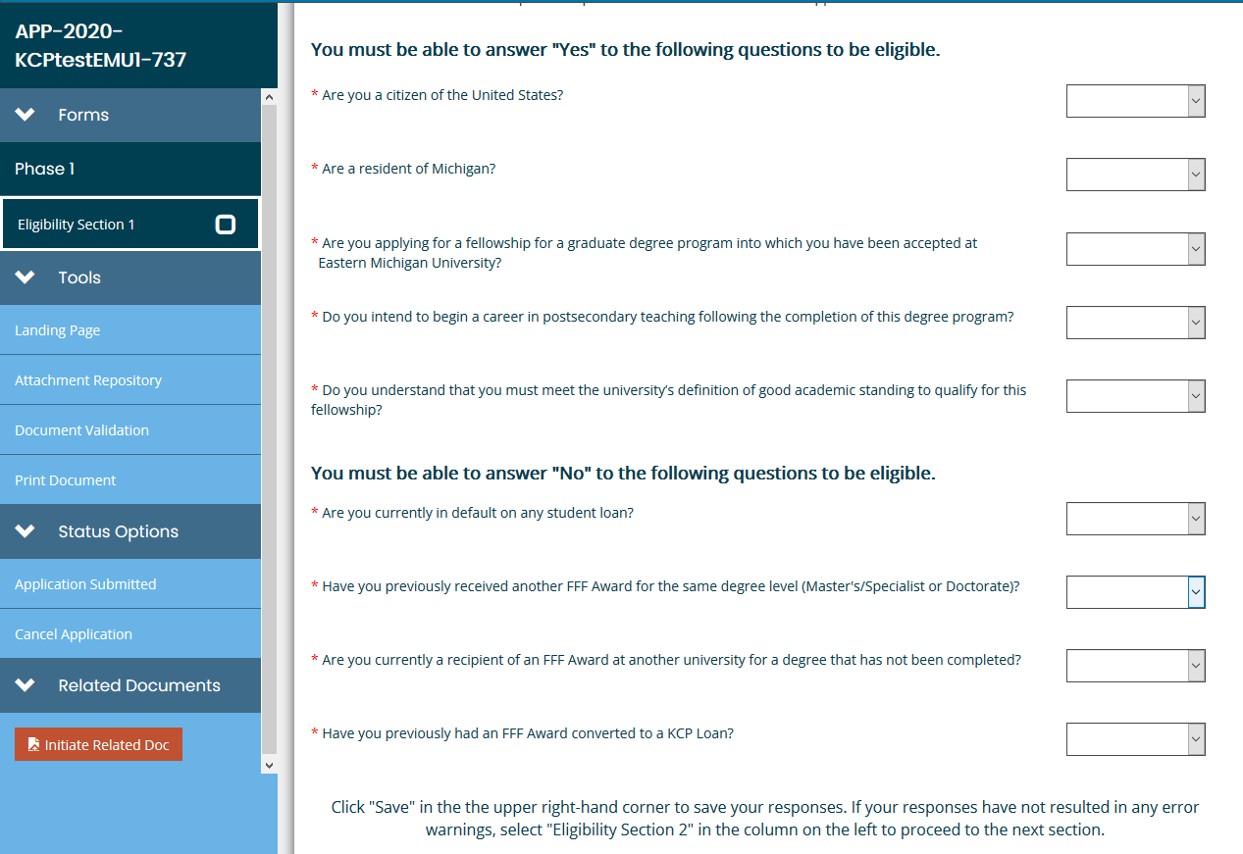
Example of ERROR message – Non Michigan residents are not eligible for the FFF Program
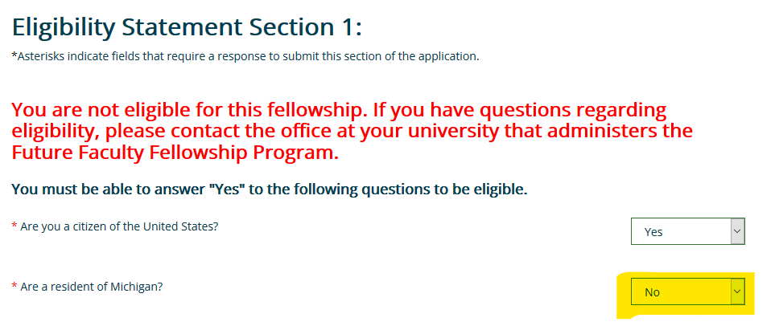
Once all questions in Phase 1 are complete, click on save in the top right corner. Once you click save, this will open up Section 2 for your completion.
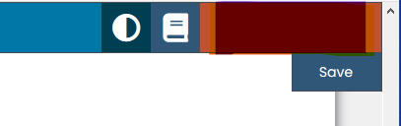
Eligibility Section 2 Asks how you are eligible for the FFF Program, once you select your choice, a box will pop up where you can upload a document. – Click save in the right hand corner when done, section 3 will then open up.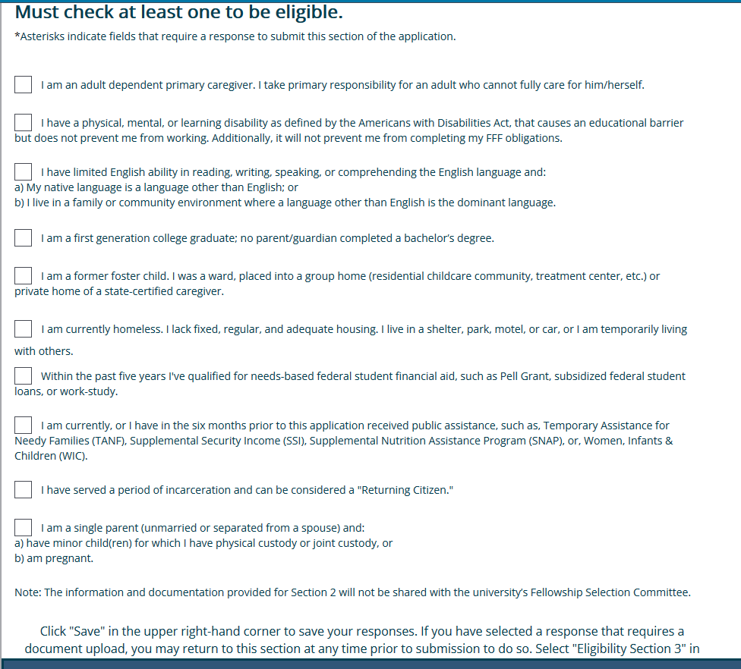

Once Eligibility 2 is complete, move on to #3
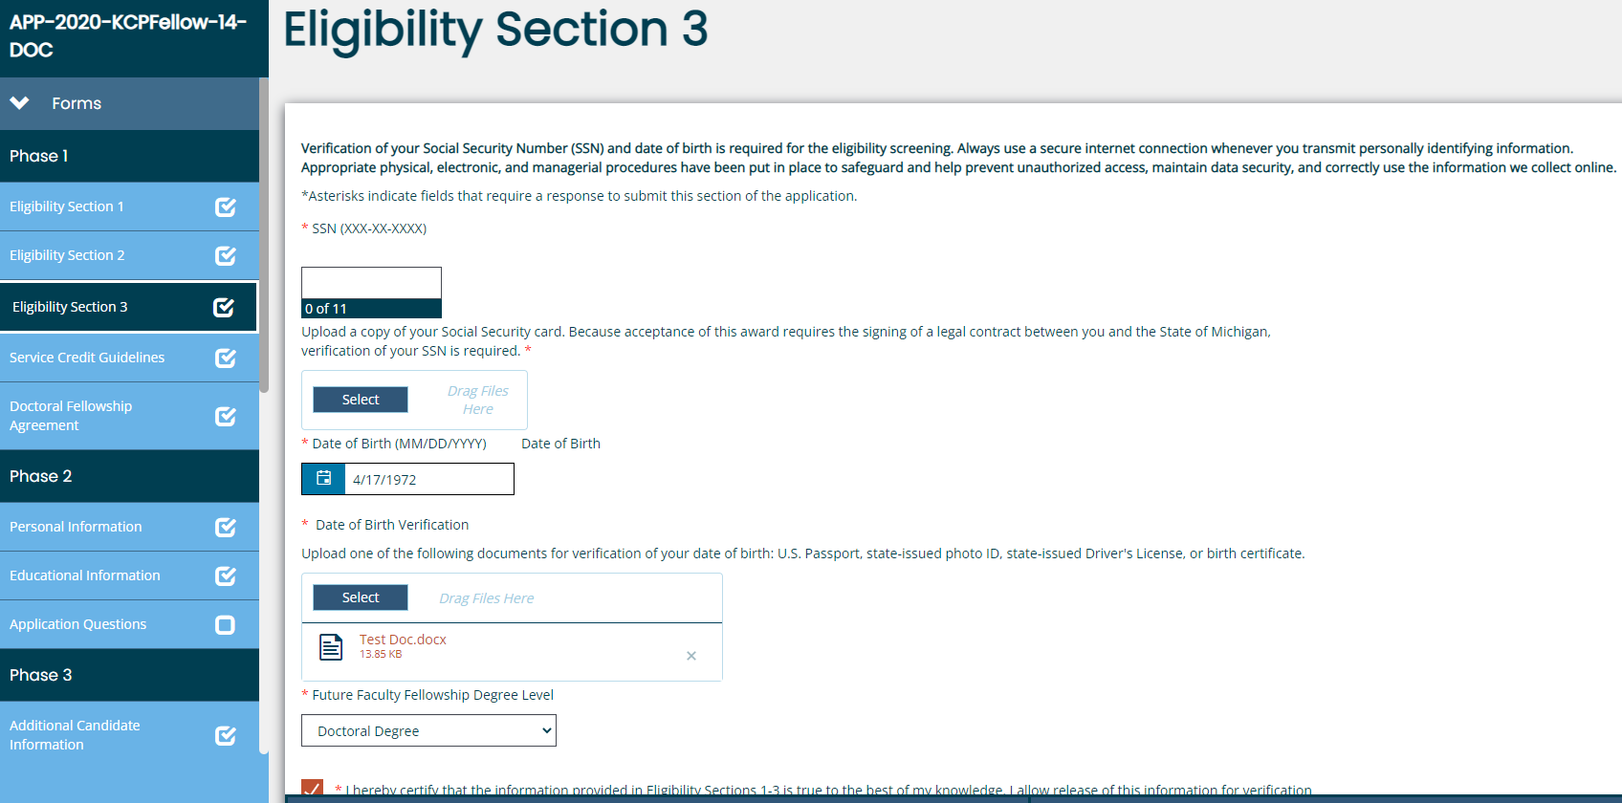
Here you will add personal information, upload documents such as a copy of your birth certificate and social security card and electronically sign.
Next you will electronically sign the Service Credit Guidelines and the Doctoral Fellowship Agreement.
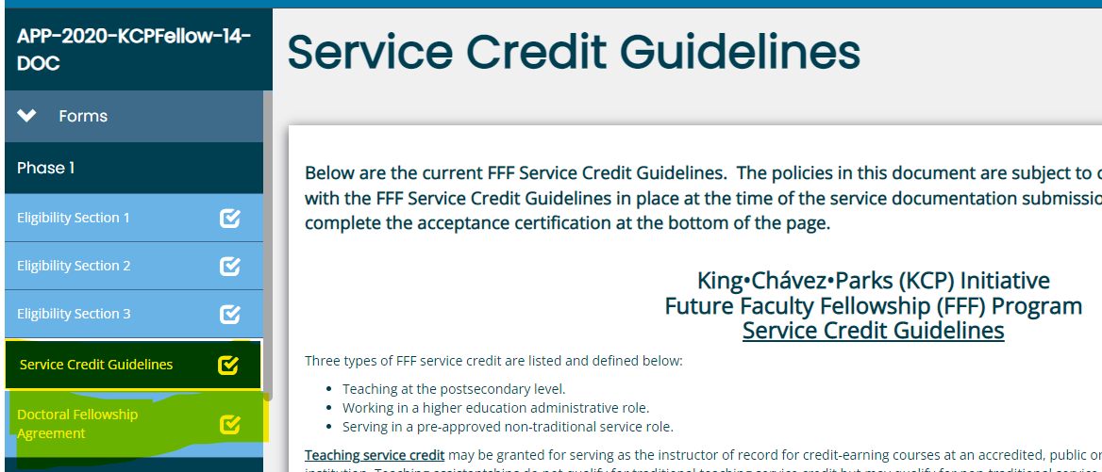
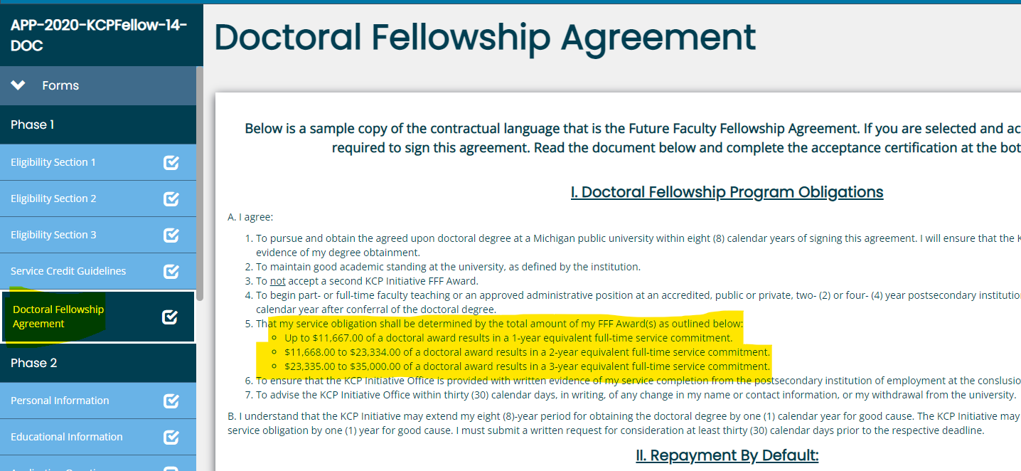
Next is Phase 2 – you will complete Personal Information, Educational Information and Application questions.
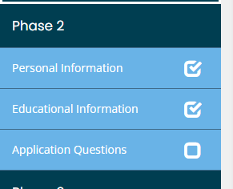

Personal Information
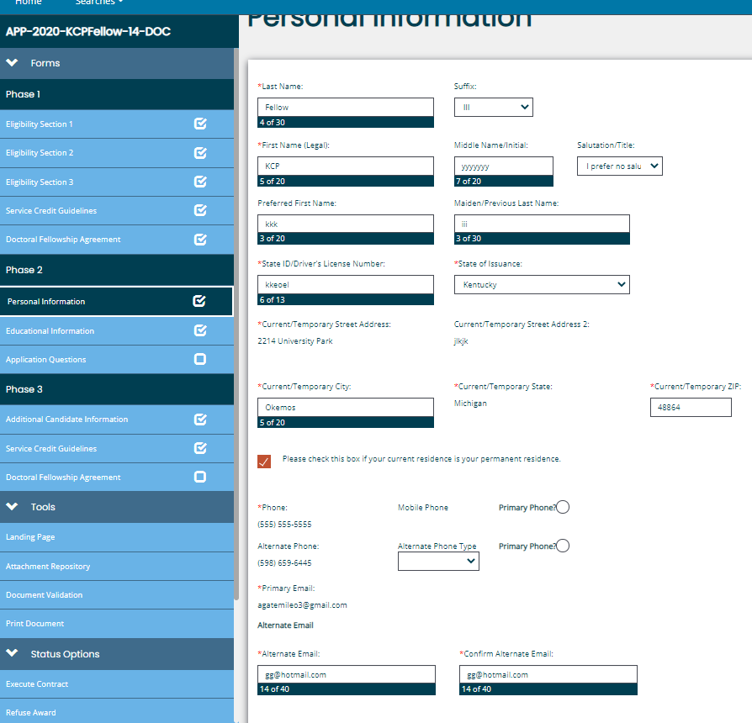

Educational Information
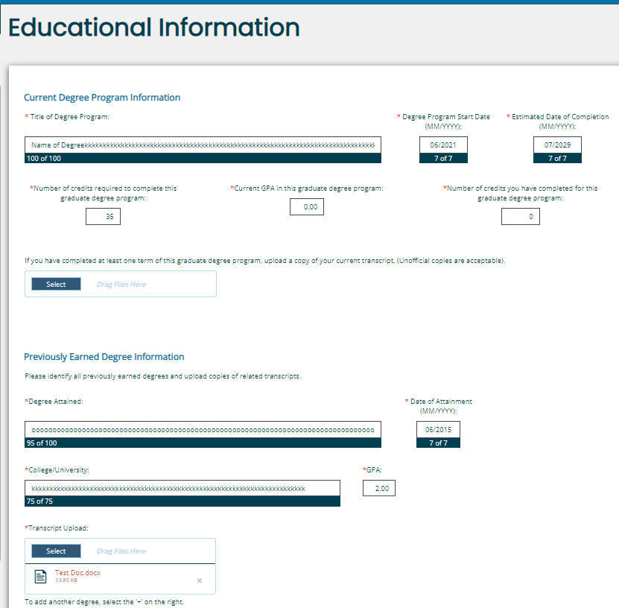

Application questions
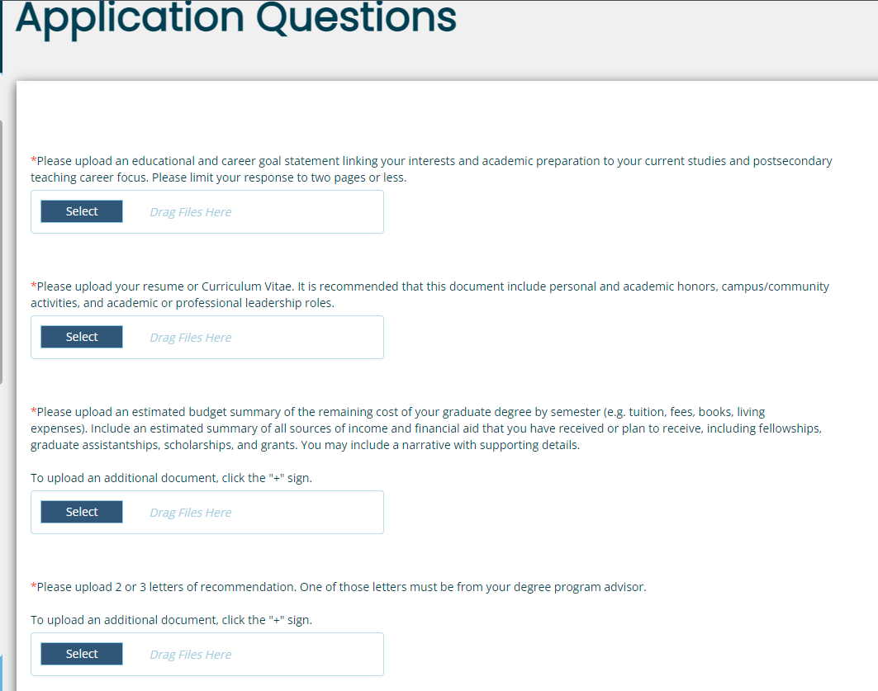
Once all sections have been completed and documents uploaded. Navigate to the left bottom of the screen and locate ‘Status Options’ select the Application Submitted. The first phase of the process is now complete. Your application will now move to the university for approval or denial. ** FYI -You will no longer see your application when you sign in… the application is now in the universities ‘my tasks’.**
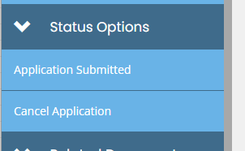

Section 3
Once you have been awarded funding from the university you will need to sign back into the system and complete the following steps.
- Under Phase 3, complete the Additional Candidate Information, Service Credit Guidelines and the Doctoral Fellowship Agreement.
- 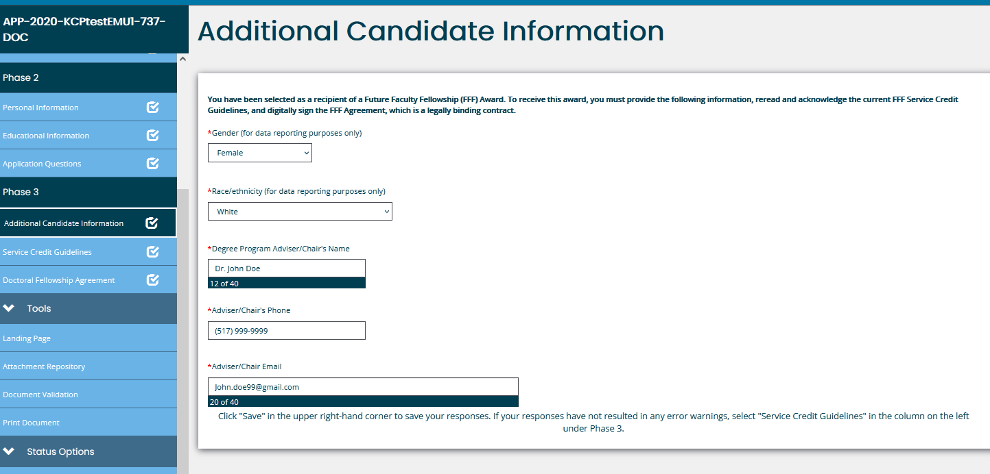
- 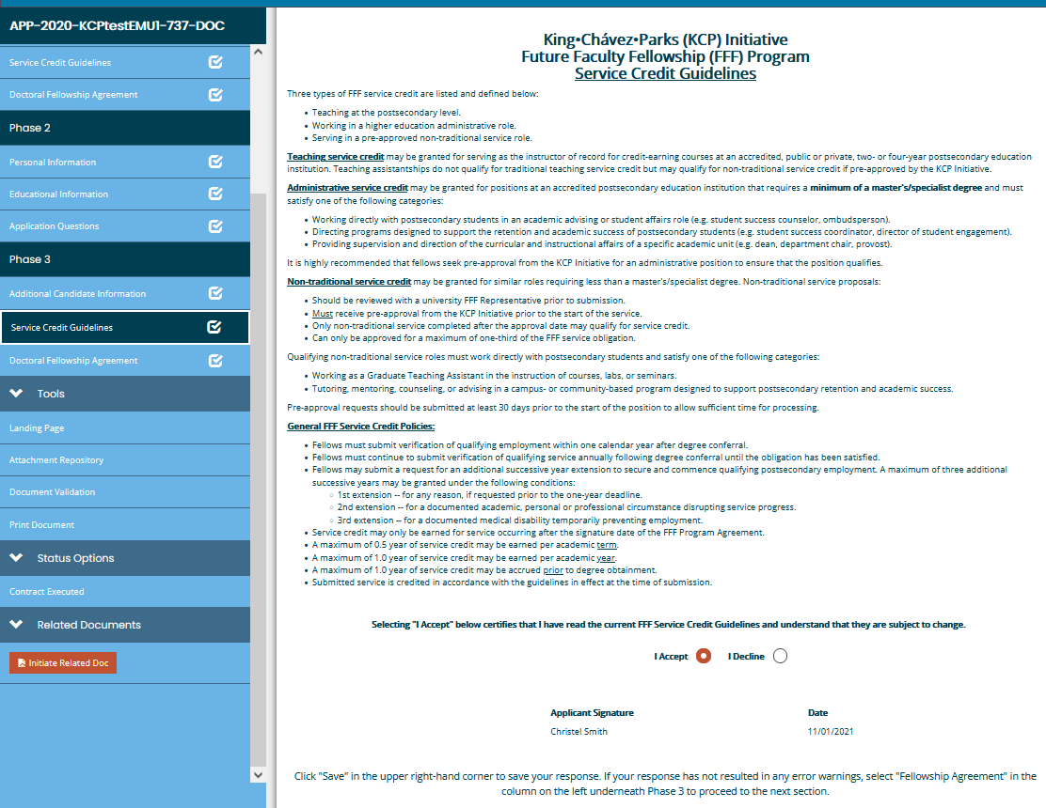
- 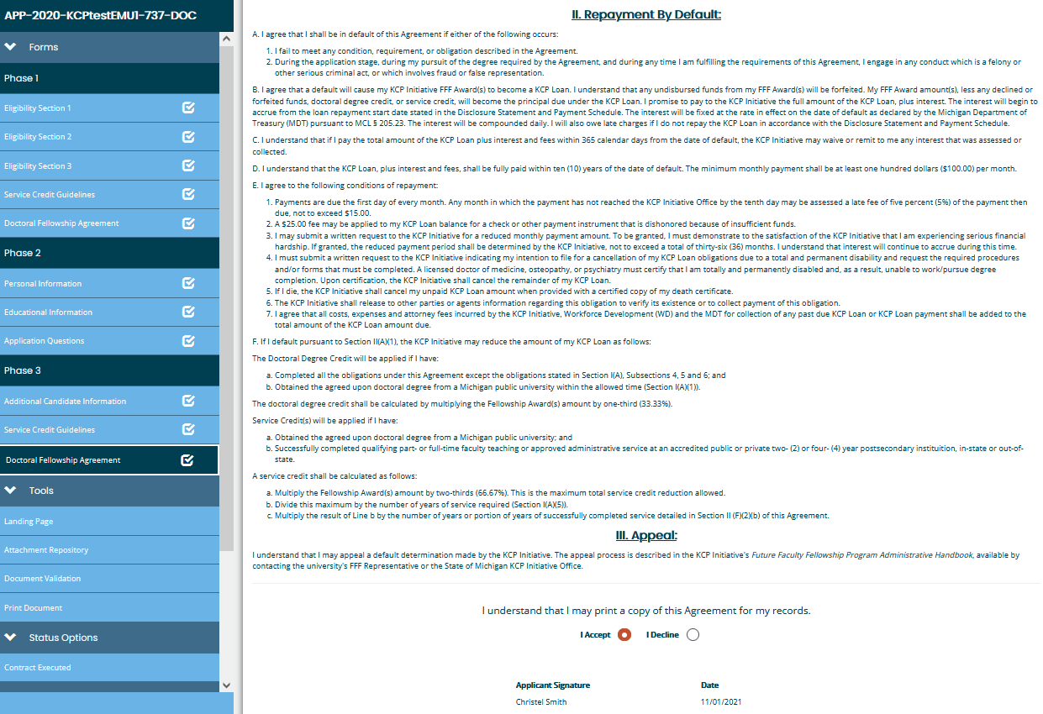
- Lastly, under Status Options (LEFT HAND SIDE)– click on CONTRACT EXECUTED
- 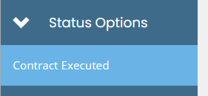
- You may now discuss disbursement of funds with your university representative.

