Complete an EPAF for the student employee. To determine whether or not a student employee needs to complete the electronic Form I-9 see examples below.
In the first example there is no current value which means they are a new employee and will need to complete an electronic Form I-9.
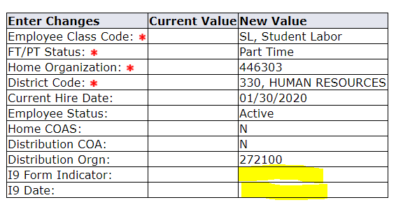
In the example below you can see that this person was employed before. However, the current value I-9 indicator says not received. This is because there was a break in service and therefore a new I-9 will need to be completed.
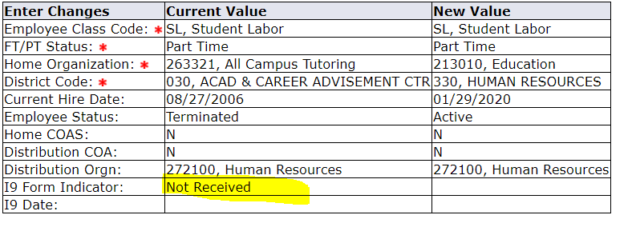
In this example you can see that the I-9 was received and there is an I-9 date. A new Form I-9 will not need to be completed in this case.

