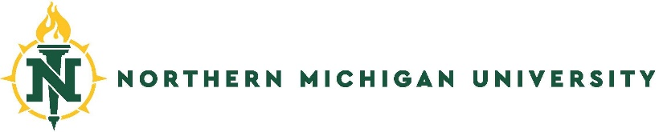
VISUAL ORGANIZER FOR STUDY ABROAD
International Education Services – 2001 Hedgcock
Northern Michigan University – Marquette, Michigan USA
+ 011 (906) 227-2510 goabroad@nmu.edu

Program Name | City, Country,  University | Program Dates | Academic Courses | Field Excursions | Program Cost(s) | Housing & Meals | Estimated Airfare | NOTES

