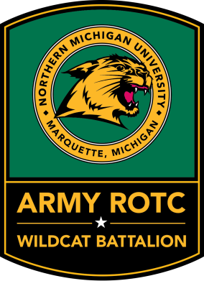
INSTRUCTIONS FOR COMPLETING A PLANNED ACADEMIC PROGRAM WORKSHEET (CC FORM 104-R)

A. PURPOSE OF 104-R: The 104-R is a PDF document used for organizing your academic plan. It is a way for cadre, staff and cadet command to monitor your degree progress, determine eligibility for scholarships/tuition assistance, and ensure academic alignment with military science courses.
B. RULES & REQUIREMENTS: The CC Form 104-R is for all intents and purposes a contract with the United States Army Cadet Command; therefore:
1. All contracted cadets and students competing for a scholarship are required to complete and update the form every semester.
2. It must be accurate, complete, and updated at least once per semester.
3. It must include grades from all previous semesters and reviewed/signed by academic advisor.
4. ROTC only gives you time to complete ONE degree. You may pursue other degrees (ie: Minors or a Double Major), but you must do so in the time frame for your primary degree (8 semesters).
5. Ensure you include your Military Science classes for each semester.
5. You must maintain full-time student status while participating in ROTC (12-18 credits). Taking greater than 18 credits per semester must be discussed with your Instructor and approved by the Professor of Military Science.
C. COMPLETION INSTRUCTIONS: Below are step-by-step instructions and guidelines for filling out the CC Form 104-R. Do not hesitate to seek guidance from your Instructor while completing the form each semester.
1. Block 1: Fill in your name (Last, First, Middle Initial)
2. Block 2: Fill in your academic major (ie: Criminal Justice, Nursing, etc.)
Block 2a: CIP Code = Classification of Instructional Program can be found online or at http://www.nmu.edu/institutionalresearch/node/1150 by searching for your academic major (ie: Criminal Justice CIP Code = 43.0104).
3. Block 3: Fill in the date you filled out the CC Form 104-R
Figure 1: Blocks 1-3 of CC Form 104-R
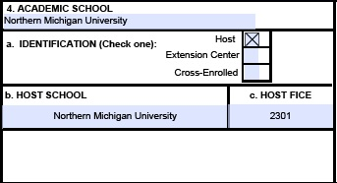
4. Block 4: Fill in the university you attend (Northern Michigan University)
Block 4a: IDENTIFICATION = Northern Michigan University is considered a Host school. Check the box next to Host [X].
Example is specific for Northern Michigan University Army ROTC cadets
Block 4b: HOST SCHOOL = Northern Michigan University should self-populate within 4b cell.
Figure 2: Block 4 of CC Form 104-R
Block 4c: HOST FICE = 2301
5. Block 5: Enter “semester” in the drop down list since NMU is based on semesters v. quarters
Block 5a: Enter the total number of credits required for your PRIMARY degree which includes your military science classes (this can be obtained online through NMU Degree Audit system, http://www.nmu.edu/bulletin1415/node/72?processtype=self&action=progrsbytype& phase=phase1&elementid=&subaction=, or from your advisor). If you are a double major or are pursuing a different minor other than military science, you only need to e nter the number of credit hours required for your primary degree.
5a (1): Enter “0” since ROTC hours are counted toward your degree at NMU
5a (2): Total Hours Rqd for NAPS self populates (it is the sum of blocks 5a & 5a1)
Additional Block 5a: Normal Academic Progression Standard self populates (this is the average number of hours a student should be taking every semester).
Block 5b: Enter the number of credits you have completed at the university that count towards your degree (not including transfer credits).
Block 5c: Enter the number of credit hours that transferred to the university and count towards your degree.
Block 5d and 5e: These values are self-populated based on what you have entered in the earlier blocks (ie: Total hours for NAPS – [Completed university +transfer credits] = Remaining # of credits for degree which is then divided into the number of semesters you have left to complete those remaining credits).
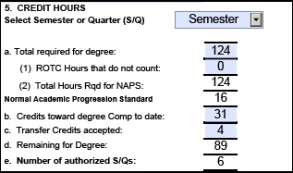
Figure 3: Block 5 of CC Form 104-R.
Here is an example for a Criminal Justice (CJ) Major (124-credit program) who is also pursuing a Military Science (MS) Minor (24-credit program, ROTC is counted). The student shows they have completed 31 credits (2 semesters) of CJ & MS classes at NMU and also received either 4 AP or college transfer credits. This means they have 89 credits left toward their degree and they are authorized 6 semesters to complete them in.

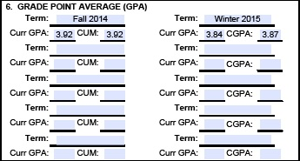
6. Block 6: Enter your semester and cumulative GPA for only those semesters at Northern Michigan University. These are updated each semester. Be sure to include all summer and online classes that count towards your primary degree.

Figure 4: Block 6 of CC Form 104-R.
7. Block 7: This block covers your entire academic plan for your degree to include courses you have taken and courses you must take to earn your degree (and also your military science minor). Transfer Students must list all classes they have taken prior to coming to NMU that count towards their degree. Label Term as “Transfer” for classes taken at a different university. Block 7 is continued on a SECOND PAGE to accommodate all of your semesters.
-Term: Fall, Winter, Summer, or Transfer
-Year: Last two digits of year course is/was taken
-No.: Course number (ie: CJ 110, MS 139, etc.)
-Course Title: This is the course prefix; it does not need the full title of the course
-Hrs.: This is the number of hours the class consists of according to NMU
-Cts.: This is the number of credits that are awarded for the class. Classes that were taken, but resulted in a failing grade will have Hrs. but 0 Cts.
-Grd.: This is the grade you received for that class; this will be blank until class is taken
-Total Term Hours: These are self-populating blocks that will show the total number of hours and credits per semester.
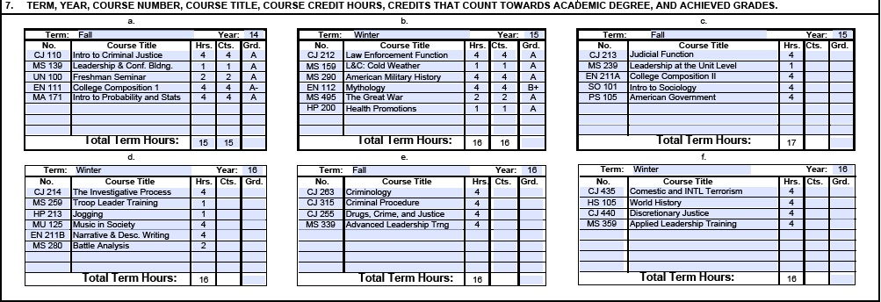
Figure 5: Block 7 of CC Form 104-R
8. Block 8: You will initial these blank spaces each time you are counseled by your instructor. The terms refers to your semester in ROTC, not that you have been counseled on each individual term. For example, a college sophomore who has taken two semesters at NMU and is being counseled during their third semester, would initial next to Term 1, 2, and 3 after the counseling session.
Figure 6: Block 8 of CC Form 104-R
9. Block 9: Your academic advisor will check “yes” or “no” based on whether or not this plan is viable. You enter the degree you are going to receive (ie: Bachelor of Science in Criminal Justice) and the date in which you will complete your degree (MM/YY).
10. Block 10: Once your Instructor approves and your Advisor has reviewed your 104-R, you will sign the box.
11. Block 11: Enter the date using the appropriate format (MM/DD/YYYY)
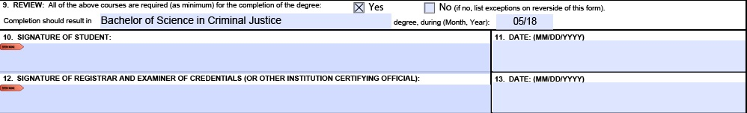
12. Block 12 & 13: Your Academic Advisor will sign and date these boxes once they have approved your CC Form 104-R and “yes” has been checked in Block 9.

Figure 7: Blocks 9-13 of CC Form 104-R
13. Page 3: Type the appropriate information where specified, then sign and date the form when you submit your CC Form 104-R to your Military Science Instructor.
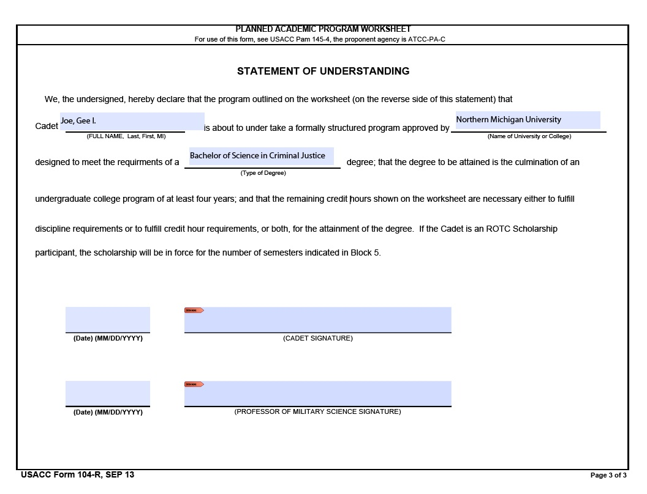
Figure 8: Page 3 of CC Form 104-R

D. DOWNLOAD & SAVE the only authorized CC Form 104-R PDF document. Contact your Military Science Instructor and/or Academic Advisor if you need additional assistance when filling out your personal 104-R.

