Marquette and NMU Attractions
All-Inclusive List for Future NMU ROTC Cadets
***
We are glad you have the opportunity to visit Marquette. We understand that you may not have much time in the area due to travel. So, to assist you in making the most of your time in the area, we would like to take the opportunity to point out some local and tourist favorites that contribute to Marquette being the “Biggest Small Town in the Upper Peninsula.” Most are just a short drive or walk from campus.

MARQUETTE ATTRACTIONS & OUTDOOR RECREATION

Dead River Falls: The trail along Dead River is an adventure in itself due to its rustic state, but it is worth every minute. There are three significant waterfalls to see.
For more information: http://www.gowaterfalling.com/waterfalls/deadriver.shtml
Other waterfalls: http://www.travelmarquettemichigan.com/category/recreation/waterfalls/

Echo Lake Nature Preserve: Echo Lake offers hikers a spectacular view of Marquette’s natural, untouched beauty. Hiking, catch and release fishing, kayaking, and canoeing are among the favorite things to do at Echo Lake.
For more information: http://www.nature.org/ourinitiatives/regions/northamerica/unitedstates/michigan/placesweprotect/echo-lake-nature-preserve.xml
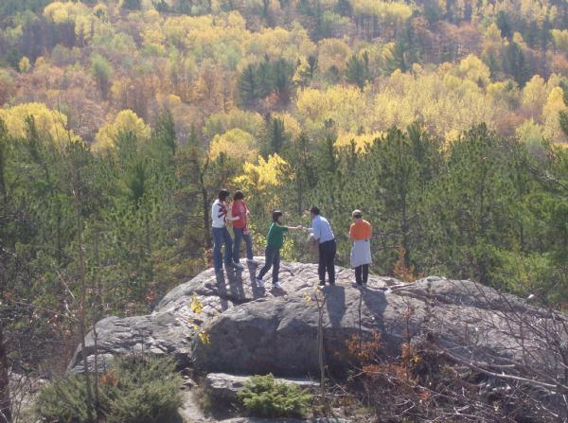
Hogsback Mountain: A more rustic route and higher view of Marquette and beautiful Lake Superior. The trail leading up Hogsback Mountain is moderately challenging and visitors should be prepared for a half-day-long trip if planning to reach the top.
For more information: http://www.travelmarquettemichigan.com/category/recreation/hiking/

Hunting & Fishing: Students can register their firearms with Public Safety and utilize approved land during hunting seasons. Fishing in any one of Marquette’s lakes and rivers is a favorite pastime in Marquette all year round!
For more information (Fishing): http://www.go-michigan.com/Marquette/Fishing/
Hunting: http://www.michigan.gov/dnr/0,4570,7-153-10363_10913---,00.html

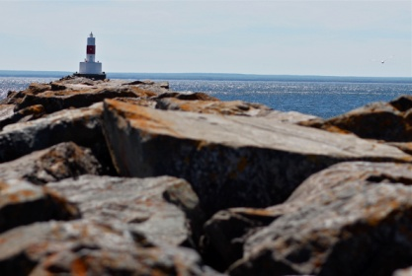
Marquette Mountain: The perfect mountain for skiing/snowboarding in the winter and hiking in the summer. The lodge offers season passes at discounted rates for students.
For more information: http://www.marquettemountain.com/

McCarty’s Cove: Enjoy a refreshing swim in Lake Superior at McCarty’s Cove beach and park.
For more information: http://www.mqtcty.org/parks-and-beaches.php

NMU Golf Course: An 18 hole, 72-par golf course covering 6,800 yards of beautiful Marquette land. Power and pull carts and equipment rentals are available. The course offers rolling terrain, water hazards, and wooded areas for the perfect golf experience. There is also a golf shop and driving range on site. For more information: http://www.nmu.edu/golfcourse/node/1

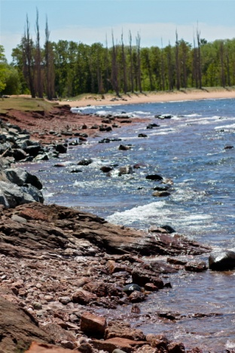
NMU Outdoor Recreation Center: The ORC leads outdoor adventure trips around the local area, holds lessons on outdoor recreational activities such as rock climbing, camping, and paddle sports, and also offers equipment rentals (kayaks, backpacks, snowshoes, skis and much more!)
For more information: http://www.nmu.edu/sportsrecsports/node/96

Presque Isle Park: This local park favorite is close to campus, and it offers a variety of fun things to do for visitors of all ages. Charcoal grills are on site and available for public use. The park has biking/hiking trails for outdoor adventure-seekers, infamous volcanic “Black Rocks” for jumping into Lake Superior, beach access, a playground for kids, and a great view of Marquette.
For more information: http://www.mqtcty.org/parks-presque-isle.php

Sugar Loaf Mountain: This is a famous Marquette attraction. Sugar Loaf Mountain offers a great view of the city of Marquette, Lake Superior, and the beautiful U.P. forest/wildlife. Stairs provide an easier route for visitors of all ages. For more information: http://www.co.marquette.mi.us/departments/planning/sugarloaf_mountain.php#.VdXJOWrUxxA

Tourist Park: This is the closest campground to campus. It is located along Dead River and amenities include restrooms, hot showers, water/electric, picnic tables, and a playground.
For more information: http://www.mqtcty.org/parks.php

8-Mile Beach: If interested in a beach campfire, 8-Mile Beach is the perfect destination. Being the only beach in town to allow bonfires, it is the perfect place along Lake Superior to view the stars and the gleaming lights of the city at night. The beach is located along M-28 when heading towards US-41 leading into Marquette.

ARTS, ENTERTAINMENT & MORE

Beaumier Upper Peninsula Heritage Center: NMU’s historical museum and educational facility features exhibits specifically honoring Michigan’s Upper Peninsula.
For more information: http://www.nmu.edu/beaumierheritagecenter/home-page

DeVos Art Museum: Part of the NMU School of Art & Design, the DeVos Art Museum features regional, national, and international contemporary art.
For more information: http://art.nmu.edu/department/museum/

Forest Roberts Theater: The Theater entertains NMU students and community members with nationally-recognized and local playwrights and musicals.
For more information: http://www.nmu.edu/forestrobertstheatre/home-page

HOTplate Pottery & Art Studio: A fun and cool place to do arts and crafts like kids. HOTplate offers the tools and work supplies needed to create your own pieces of art. You can paint your own pottery or create fused glass. For more information: http://hotplatepottery.com/
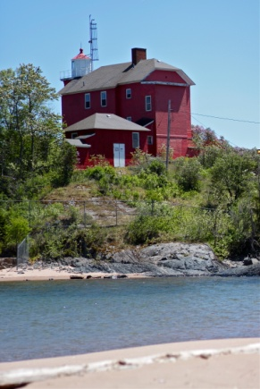
Marquette Maritime Museum: A great place to learn about Great Lakes Maritime history and view the shipwreck displays. Tours of the Harbor Lighthouse are available and the pier is open for walking in good weather conditions. For more information: https://mqtmaritimemuseum.com/

NMU Campus Cinema: This is an NMU student-run organization that shows new movies on campus for free for NMU students.
For more information: http://campuscinemanmu.weebly.com/

NMU Sporting Events: Northern Michigan University offers a variety of sporting events for entertainment and student involvement. The football team plays home games in the Superior Dome, the largest dome in the world; the hockey team dominates the ice in the Berry Events Center; and many other sports teams provide live entertainment to students all week long.
For more information: http://www.nmuwildcats.com/landing/index

Thomas Theater Group: The cinema plays a variety of the newest movies, has flexible show times, and offers VIP or TSX (large format) seating for reasonable prices.
For more information: http://www.thomastheatregroup.com/

LOCAL DINING LOCATIONS

Aubree’s Pizzeria & Grill: Great pizza, great atmosphere and right in the heart of Marquette
For more information: http://www.aubrees.com/

Babycakes: Popular downtown bakery. Well-known for their muffins and strong cups of coffee.
For more information: http://www.yelp.com/biz/babycakes-muffin-company-marquette

Border Grill: Delicious, market-fresh and fast Mexican food made to order
For more information: http://bordergrill.net/

Buffalo Wild Wings: Your favorite chicken wings and sports broadcasting location
For more information: http://www.buffalowildwings.com/en/locations/Detail/3508

Coachlight Restaurant: Reasonably-priced breakfast and lunch restaurant
For more information: http://www.yelp.com/biz/coachlight-restaurant-marquette

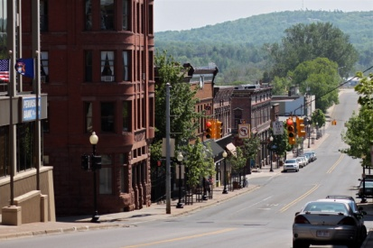
Donckers: Soda Fountain, ice cream and gift shop, candy counter & restaurant all-in-one location
For more information: http://www.donckersonline.com/

Frosty Treats: One-stop-shop for ice cream favorites (NOTE: cash only)
For more information: http://www.yelp.com/biz/frosty-treats-marquette

Hudson’s Classic Grill: Retro throw-back burger, fries, and shake American food restaurant
For more information: http://hudsonsmarquette.com/

Huron Mountain Bakery: Freshly-baked doughnuts, muffins, bagels and gourmet sandwiches
For more information: http://huronmountainbakery.com/

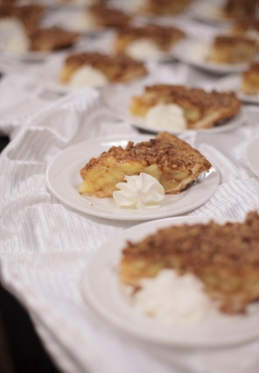
Jeffrey’s Restaurant: Traditional diner food and a great breakfast, well-known for their pies
For more information: http://www.yelp.com/biz/jeffreys-restaurant-marquette

Jean Kay’s Pasties: Pasties are considered the food staple of the U.P. and they are right next to campus
For more information: http://jeankayspasties.com/

Lagniappe’s Cajun Creole Eatery: Authentic Cajun food with down-south favorite dishes
For more information: http://marquettecajun.com/

Lake Superior Pizza & Sub Company: Well-known for their version of the personal pizza: the pizza roll
For more information: http://www.yelp.com/biz/lake-superior-pizza-and-sub-co-marquette-2

L’Attitude: Trendy and chic café and bistro with a great view of Lake Superior
For more information: http://lattitudecafe.com/

Main Street Pizza: Thick-crust, brick-oven pizza
For more information: http://www.allmenus.com/mi/marquette/18238-main-street-pizza/menu/

Portside Inn: Full American menu with Maritime theme and decor
For more information: http://theportsideinn.com/

Sol Azteca: Authentic Mexican food and a restaurant with a view
For more information: http://www.yelp.com/biz/sol-azteca-marquette-2

Stucko’s: Great burgers and all your BBQ favorites
For more information: http://stuckospub.com/

Sweet Water Café: Local foods eatery, known for their breakfasts and art displays
For more information: http://sweetwatercafe-mi.com/
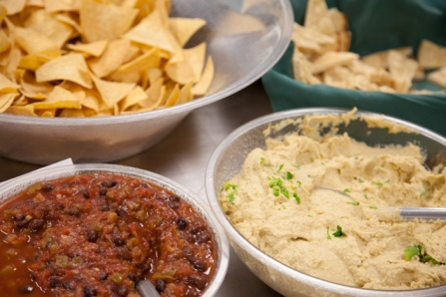
Third Street Bagel: Bagels, breakfast sandwiches, and coffee shop
For more information: http://www.thirdstbagel.com/

Toarmina’s Pizza: Known for its 24-inch pizza option, great when serving a large group
For more information: http://www.toarminas.com/toarminas-marquette-michigan/

Vango’s: Another great pizza location and also authentic Greek cuisine
For more information: http://www.vangospizza.com/

