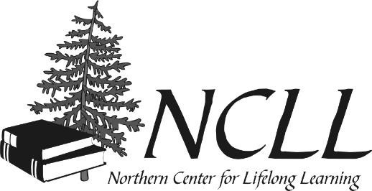
PROGRAM/EVENT SUMMARY SHEET
This document is available for download at
https://nmu.edu/ncll/programs-events-and-resources

Liaison name: ____________________________________ Program/Event #:___________

Program/Event Title: _________________________________________________________
Program/Event Term: ________________________________________________________

Number of participants attending: Members: _______ Non-Members ______ TOTAL ______

Number who evaluated the presentation as: Excellent _____ Good _____ Average_____
Compliments offered: (Indicate where if you submitted these comments elsewhere.)

__________________________________________________________________________

__________________________________________________________________________

Suggestions for improvement:

__________________________________________________________________________

(Note: Portion below is for NCLL office use only. May copy above information and provide to presenter.)

Program ideas for future presentations: ____________________________________________________________________

Other programs the presenter(s) might be willing to present: ____________________________________________________

How you learned about this program if not a member (circle answer) Mining Journal, Marquette Monthly, friend, NCLL web site, Facebook, other
_____________________________________________________________________________________________________

List total money collected for programs at event, from whom, for what, amount, cash or check, and submitted to NCLL office.
Use back of form if needed: __________________________________________________________________________________ _____________________________________________________________________________________________________

Number of new memberships (from whom, how many forms and waivers, check or cash. List here or use back of form if needed _____________________________________________________________________________________________________ _____________________________________________________________________________________________________

____ Thank you card enclosed or note sent to presenter(s)
____ Copy of the above portion of this summary sheet provided to presenter(s)
____ Two complimentary class cards provided to each presenter of this program/event for NCLL’s fiscal year
(each class fee valued at $5 per member or $10 for non-member)

