ASSESSMENT & EXAM MODELS
Auscultation Trainer and Smartscope
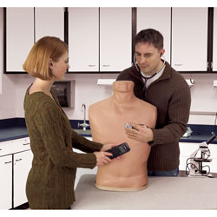  http://www.enasco.com/pdfs/lf01142.pdf | Skills  - Invisible Auscultation Sites  - Palpable Landmarks  - 12 Different Heart Conditions  - 16 Different Lung Conditions  - Amplified Speaker  - Trainer Stethoscope (two sets of ear-pieces)

Breast Self-Exam Models
We have numerous models. This picture is just one example:
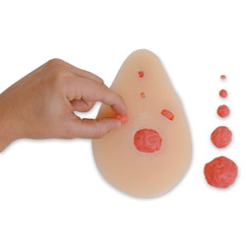  http://www.enasco.com/product/SB23327U | Skills for all BSE Models:  - Life like feel  - Practice BSE technique  - Different size nodules and lumps  - Different size breasts  - One Strap on Model Available

Testicular Self-Exam
We have multiple models.
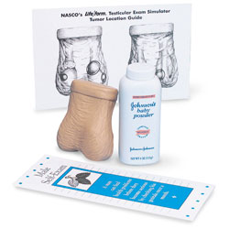  http://www.enasco.com/product/LF01143U | Skills for all TSE:  - Life like feel  - TSE technique  - Different sizes and number of lumps in testicles

Adam Rouilly Eye Exam Trainer
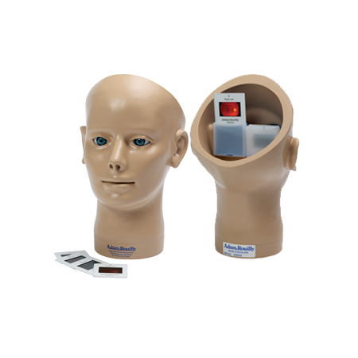  http://www.adam-rouilly.co.uk/productdetails.aspx?pid=2662&cid=383 | Skills  - Practice eye exam technique  - Interchangeable conditions and diseases
Adam Rouilly Ear Exam Trainer
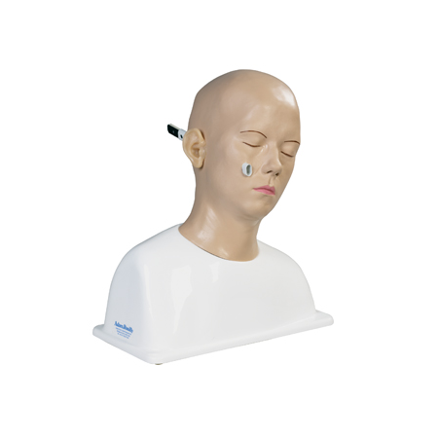  http://www.adam-rouilly.co.uk/productdetails.aspx?pid=2643&cid=376 | Skills  - Practice ear exam technique  - Interchangeable conditions of the tympanic membrane
ZOE® Gynecologic Pelvic Exam Simulator
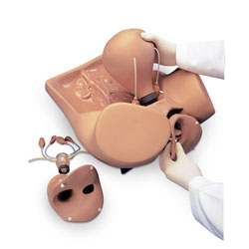  http://www.enasco.com/pdfs/SB28796.pdf | Skills  - Relevant internal landmarks  - Anatomically correct  - Bi-manual pelvic exam  - Palpable normal and pregnant uteri  - Vaginal exam  - Visual recognition of normal and abnormal cervices  - Uterine sounding  - IUD insertion and removal  - Lap visualization and occlusion of fallopian tubes

Prostate Exam Simulator
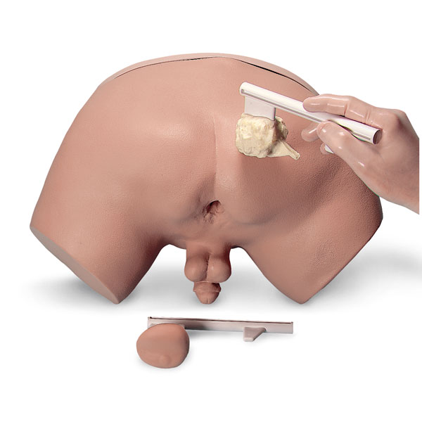  http://www.enasco.com/pdfs/lf00901.pdf | Skills  - Prostate exam techniques  - Four different prostate glands  - 1 benign  - 3 stages of prostatic carcinoma in varying degrees

