Anatomical Models
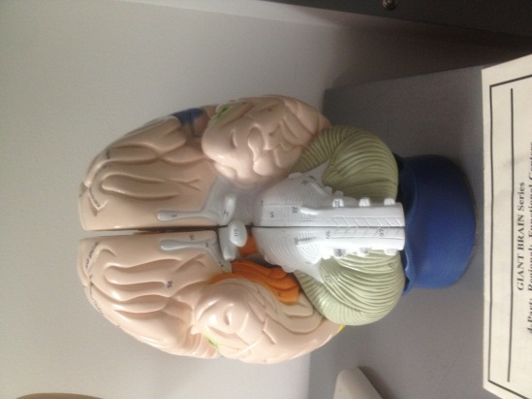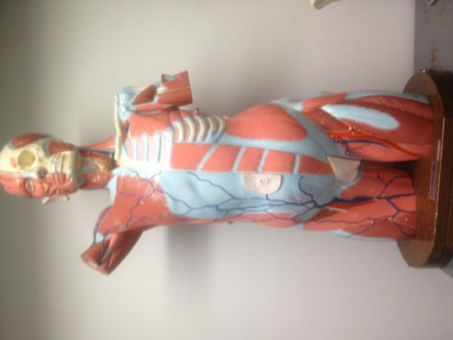  http://www.anatomywarehouse.com/complete-dual-sex-muscular-torso-anatomy-model-3515  http://www.mooremedical.com/index.cfm?PG=CTL&CS=HOM&FN=ProductDetail&PID=14229  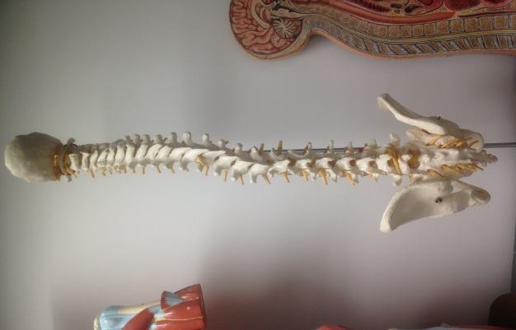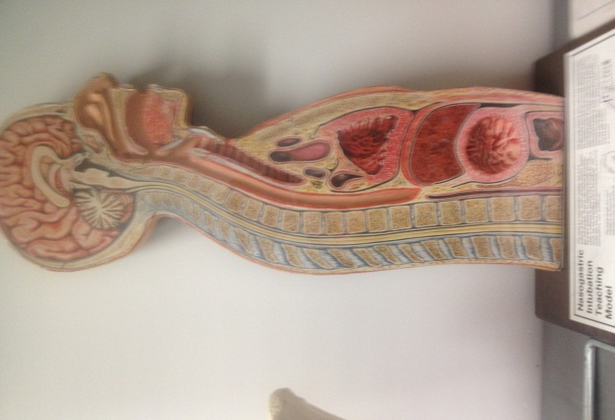  http://www.anatomicalmodel.eu/nasogastric-tracheostomy-teaching-torso  http://www.meditechvisualaids.com/stock-models/ | Skills  - Numerous different anatomically correct models  - Brain  - Torso  - Spine  - Sagittal view NG placement
Lung Model with Larynx
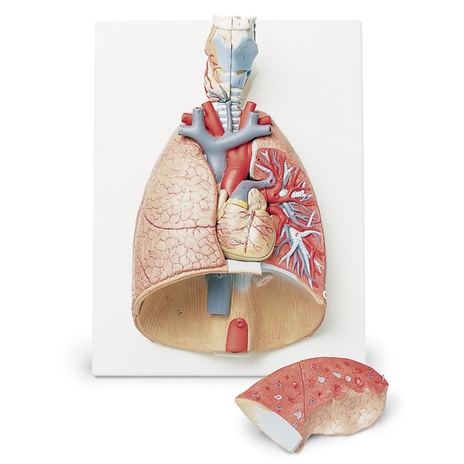  http://www.enasco.com/product/SB41144 | Skills  - Two Part Removable Larynx  - Trachea w/ Bronchial Tree  - Two Part Removable Heart  - Subclavian Artery and Vein  - Vena Cava  - Aorta  - Pulmonary Artery  - Esophagus  - Two Lungs w/ Removable Front Halves  - Diaphragm

Heart on Stand
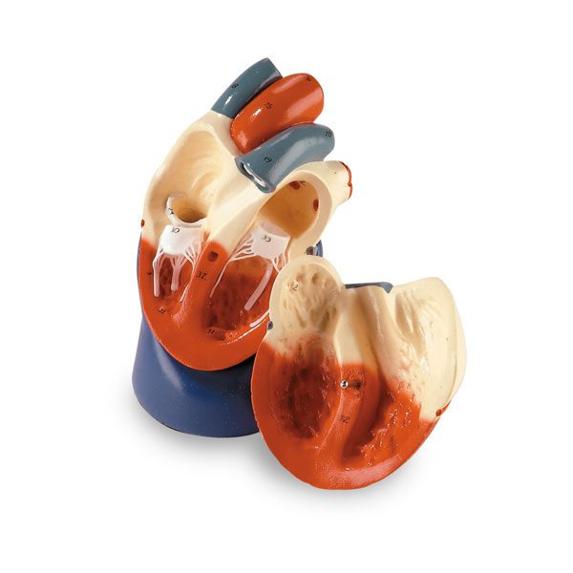  http://www.enasco.com/product/SB38722U | Skills  - Two part dissection  - Detailed Valves and Chambers  - 36 Labeled Structures

Giant Teeth and Toothbrush
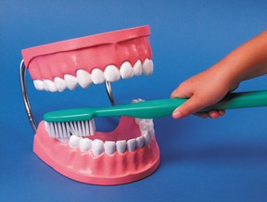  http://www.childbirthgraphics.com/index.php/shop-by-type/anatomical-models/teeth-model-with-toothbrush.html | Skills  - Dental Hygiene  - Tooth care  - Use putty to simulate plaque

