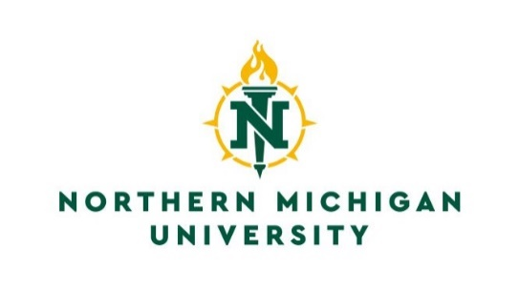

Registrar’s Office
C.B. Hedgcock, Room 2202
1401 Presque Isle Avenue
Marquette, Michigan 49855
(906) 227-2278
(906) 227-2231 Fax
Email: records@nmu.edu

Request Release of Directory Information

I previously requested Northern Michigan University to prevent the disclosure of my directory information. Now, I would like to have those directory restrictions removed from my academic record. It is my desire that Northern Michigan University make my directory information available.

I agree that the items selected below are designated as directory information at Northern Michigan University and may be released for any purpose at the discretion of NMU faculty and staff.

I _______________________________________________________, _________________________________,
PRINT OR TYPE FULL NAME NMU IN

request that Northern Michigan University remove the directory restriction information checked below:

___NAME & ALL DIRECTORY INFORMATION LISTED BELOW (name and all other information).
___LOCAL ADDRESS AND TELEPHONE
___PERMANENT ADDRESS AND TELEPHONE
___ENROLLMENT STATUS [Enrollment status, major/minor, program level (e.g. vocational, undergraduate, etc.), class standing, date(s) of attendance, current candidacy for degree or certification, degree(s) earned (including dates), honors and awards].
___NMU EMAIL ADDRESS (NMU email address will continue to be used as the official means of communications at this university. Only the printing of it in the online directory will be restricted.)

SIGNATURE: _______________________________________________ DATE: ______________________
Return this form to the above address for processing.

For Office Use
Confidentiality Flag Removed on Banner: _______
Processor’s Initials: ________

