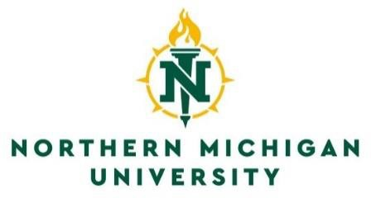
Registrar’s Office
C.B. Hedgcock, Room 2202 1401 Presque Isle Avenue Marquette, Michigan 49855
(906) 227-2278
(906) 227-2231 Fax
Email: trnseval@nmu.edu

Northern Michigan University and North Central Michigan College Reverse Transfer Transcript Release Form
Please complete and return to:
Registrar’s Office
C.B. Hedgcock, Room 2202 Northern Michigan University Marquette, MI 49855
Email: trnseval@nmu.edu
Mount Pleasant, MI 48859
Phone: (989) 774-3261 Fax: (989) 774-3783
PERSONAL INFORMATION

NMU ID # North Central Michigan College ID #
Name Last First Middle
Previous Last Name (if applicable)

Birthdate (MM/DD/YYYY) Current e-mail address
Current mailing address:

Number and Street City State Zip Code Daytime phone number ( )
Date last attended North Central Michigan College
MAILING INFORMATION
Please forward a transcript to:
North Central Michigan College
Registrar’s Office, Attn: Reverse Transfer 1515 Howard St
Petoskey, MI 49770
2274 Enterprise Drive
Mount Pleasant, Michigan 48858
AUTHORIZATION TO RELEASE ACADEMIC RECORDS
FERPA COMPLIANCE - I authorize Northern Michigan University to send my transcript to North Central Michigan College for review under the Reverse Transfer Agreement. I also authorize North Central Michigan College to:
- evaluate to determine if I am eligible for an associate’s degree
- release the results of their graduation review to Northern Michigan University of outstanding requirements
- send a transcript to Northern Michigan University if a degree is awarded

Student Signature Date
Federal law requires the student signature for release of transcripts. All holds must be cleared before submitting a transcript request.

Updated for ADA 02/2026

