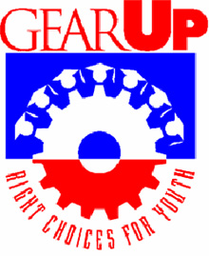
FAMILY NEWSLETTER
April/May 2014

GEAR UP families, parents and guardians,
Do you have a college education? Or have you thought about taking some classes for fun? There are many options to explore here at Northern Michigan University.
Did you know there are over 180 programs you can enroll in ranging from a one-year certificate to master’s programs? Class sizes are small enough to give you that personalized feeling, professors are available during office hours, and technology is changing and developing daily.
There are options for new students, transfer students, reentry students, veterans, and graduate students. You often have the option of taking classes on-line as opposed to coming to campus.
For more information, check out these likes:
General Admissions: www.nmu.edu/NMUadmissions
There are several links to the other areas listed above. There are also tabs where you can check out programs, classes, requirements, tuition costs, fees, student groups and every other bit of information you may want about coming to NMU.
If you’d like to talk to someone, feel free to call 906-227-2650.

10 Ways that having a summer job will help your student
- Having a job builds confidence
- Try out a new surrounding
- Take on new responsibilities
- Working improves time management
- Helps to set priorities
- Learn to balance work and time for yourself
- Jobs obviously add to your resume
- Get some valuable experience
- Even volunteering counts
- Real life experience prepares them for their future
- Do they like to work with people?
- Do they prefer to work with numbers?
- Can they work well under pressure?
- What kinds of jobs do they like or dislike?
- Having a job increases their networking ability
- Mostly they are around people their own age now. But having a job helps them to meet others who may become valuable resources for other jobs/positions
- Co-workers and supervisors make valuable references for future jobs
- Working improves their money management skills
- Your student learns how much to save or spend
- They also learn about having taxes deducted from their checks
- Having jobs teaches them to ask questions
- Asking questions shows interest in learning their job
- Asking questions also improves communication skills
- Working teaches life skills, like staying positive
- Every job is important
- Doing little things well and with a smile can lead to more responsibility or being asked to return the next summer
- Having a job and excelling at it may lead to other jobs
- Teach your student to go “above and beyond” what is asked of them
- If they finish a task early, they should ask for more to do, and do it well
- Real world jobs prepare them for life after high school
- Encourage your student to listen to other people’s point of view
- Skills your student learns today will help them prepare for their future

GEAR UP SRPING BREAK TOUR 2014
During Spring Break, North Star Academy joined with Sault Ste. Marie High School to tour six colleges and universities in the Lower Peninsula. Students visited Grand Valley State University, Ferris State University, Alma College, Delta College, Northwood University and Saginaw Valley State University. The counselors and the bus driver all survived!
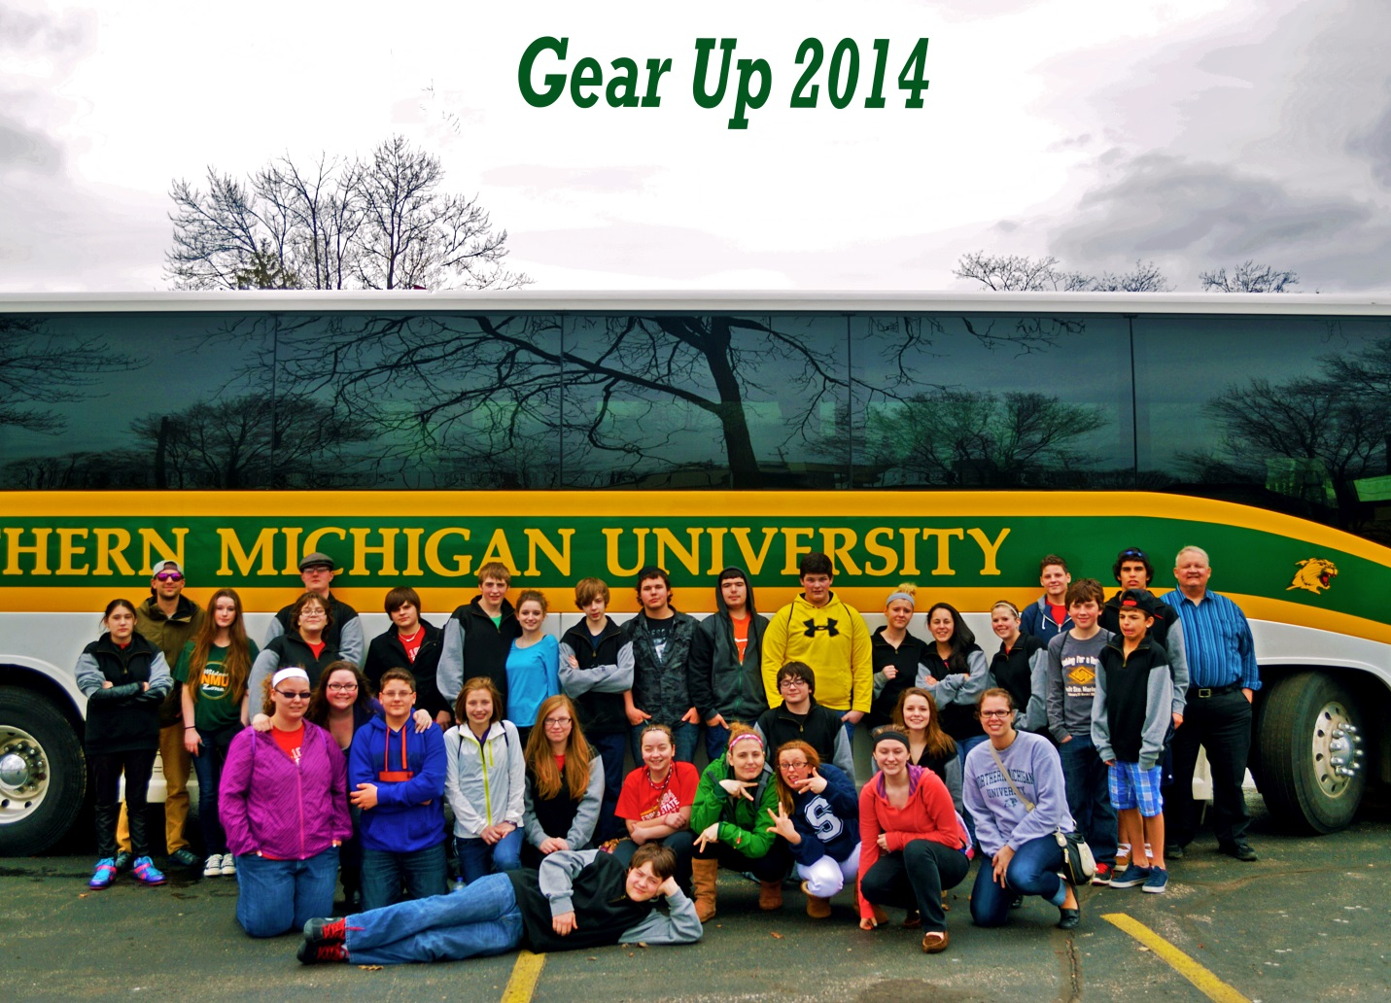
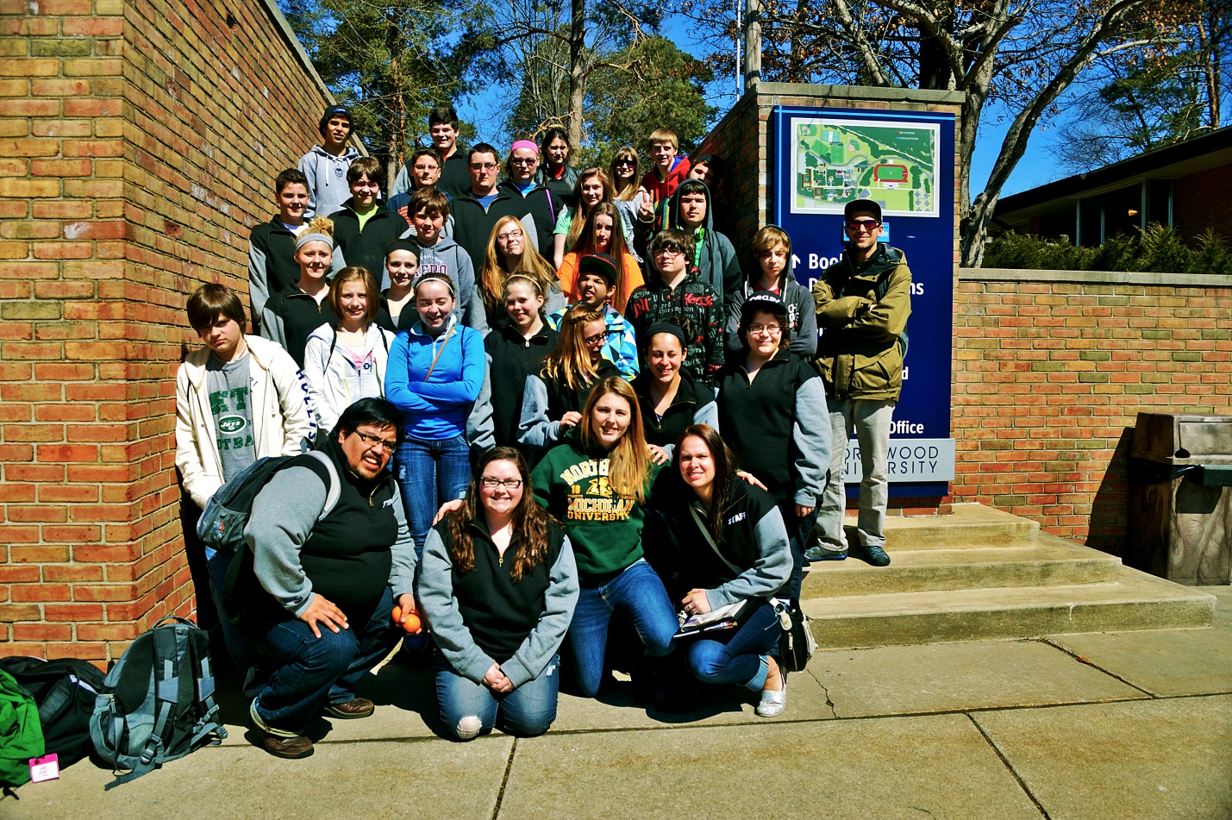

Spring Break Counselors included:
Meredith Waara, GEAR UP Student Coordinator
AJ Lara, MERC Graduate Assistant and Jump Start Student Coordinator
Kelsey Ferguson
Corinne Hooper
Levi Warnos

North Star Academy participants included: Nick Bandman, Lucas Buruse, Dakota Castello, Kathleen Grizzel, Jacob Jandreau, Zofia Kibit, Ceara Marunde, Gage Nutt, Tallen Prisk and Spencer Tappy.
Sault Ste. Marie participants included: Brittany Bell, Alaysia Brewer, Shelley Britton, Hunter Brown, Sarah Burke, Scott Burt, Anthony Cress, Jarrett Feltis, Tyler Feltis, Paula Hanskett-Nolan, Miala Hyde, Corbin McConnell, Elijah McCoy, Taylor Mackety, Dakota Nolan-Miller, Ashley Robinson, Connor Tetzlaff, and Jessica Thompson.

REGISTRATION NOW OPEN FOR SUMMER CAMP 2014!

By now you should have received the application forms in the mail. If you haven’t, or need a new one, they are available in the office at North Star Academy, on NMU’s GEAR UP website at www.nmu.edu/gearup or by calling NMU’s GEAR UP program in the Multicultural Education and Resource Center at 906-227-1554.

As part of camp they will be visiting historic Fort Mackinac on Mackinac Island and touring North Central Michigan College.
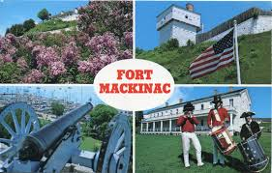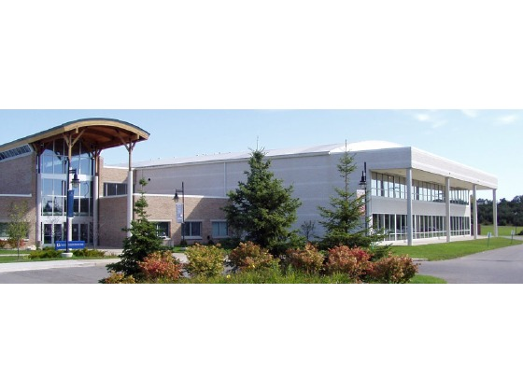
Camp dates are June 22-28. All housing, meals and activities will be fully paid for by GEAR UP. Students will also learn more about college life, stay in a residence hall, eat in one of the on-campus dining halls, learn leadership and team-building skills, and make new friends. Potential activities include behind the scenes tours of Forest Roberts Theater, a nursing presentation, and some hands-on activities in science. There will also be plenty of time for outdoor activities!
Your student won’t want to miss a single minute of this experience. Every GEAR UP activity they participate in increases their chances at earning a GEAR UP scholarship for college in Michigan.

If you have any questions feel free to contact:
Shirley Brozzo, GEAR UP Director or Meredith Waara, GEAR UP Student Coordinator at
906-227-1554.

