PARENT NEWSLETTER
February 2014

File Your 2013 Tax Return For FREE!

"What SmartMove will you make this tax season?" NCTC's SmartMove Program is back by popular demand! It's a safe, free and convenient way to file your tax return. Learning to file your own tax return will equal a lifetime of savings.
- Who Qualifies?
Individuals or families with a combined income under $58,000 in 2013

- What is needed?
- A valid email address
- Income Forms (W-2’s, 1099’s, 1098’s) (document checklist)
- SSN for taxpayer and dependents
- If you have it last year’s AGI, tax return, and Electronic PIN

- When is the tax day deadline?
You have until Tuesday, April 15th, 2014 to file your 2013 federal and state taxes.

Ready to make a smart move? Use this link: www.myfreetaxes.com/NCTC_MIGEARUP

Dangerous New Drug on the Rise
By Meredith Waara, GEAR UP Student Coordinator

Have you ever heard of “sizzurp?” It’s not in the dictionary and is not sold in the pharmacy. This drug has been gaining popularity with hip-hop artists and is seen around the internet on social media and in music videos. But what is it and how is it made? What are the consequences of abusing this new drug?
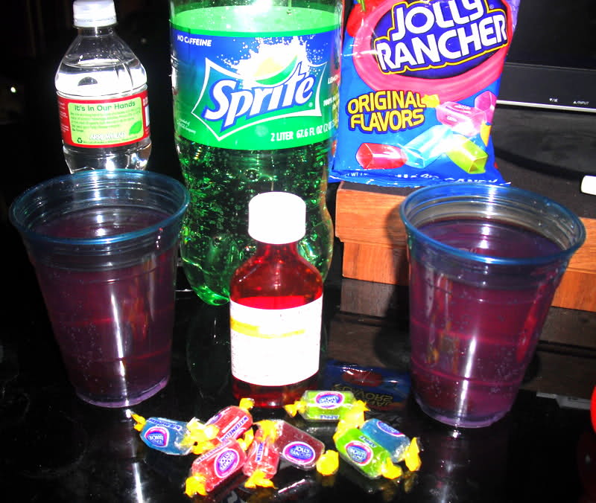
“Sizzurp” (also known as “purple drank”, “water”, or “lean”) is made by combining prescription cough syrup with sweet hard candies and some type of pop. The resulting drink is said to be deliciously sweet, but the drinker can suffer major consequences after consumption. Prescription cough syrup contains codeine, an opiate in the same family of drugs like heroine and morphine, which is very addictive in doses larger than recommended. It serves as a pain reliever and is the reason why certain cough syrups can only be purchased if you have a prescription. Signs of codeine abuse include nausea, vomiting, and drowsiness. Codeine also suppresses breathing. Slowed breathing or difficulties catching a breath are also symptoms. Codeine affects mental capacities as well with symptoms ranging from confusion and irritation to hallucinations or even seizures.
According to a study done by the U.S. Drug Enforcement Administration, 1 in 10 teens admit to using “sizzurp”. With this new drug being glorified in pop culture and online, parents should be aware of the risks and side effects of its usage. Knowing the signs and symptoms of usage is important. By simply taking the time to remind your kids about the dangers and consequences of using or abusing prescription or other drugs will have a lasting effect.

Sources: http://www.today.com/news/whats-sizzurp-dangerous-way-kids-get-high-2D11976739
http://www.drugfree.org/newsroom/rapper-lil-wayne-released-from-hospital-after-seizures-linked-to-reported-use-of-sizzurp?gclid=CJSqw8P_pbwCFcVFMgodKnEATg
http://www.narconon.org/drug-abuse/codeine-effects.html

Help your student get ready for college
Two great ways to help your child get ready for college are to start doing your scholarship research and start to visit colleges and universities. GEAR UP can help with both of these activities. Here are several websites you can search to find scholarships that might be right for you. Don’t wait until the last minute. By the time you get to Senior year, you need to be applying for scholarships, not hunting for them. Begin your search at these sites:
www.finaid.org www.fastweb.org
www.xap.com www.collegeboard.com
www.allaboutcollege.com www.scholarships.com
www.collegeview.com www.review.com
www.scholarshipexperts.com www.collegeanswer.com

Financial Aid Workshop
Learn more about what it is you need to do financially to get prepared for your student’s college career. Learn the jargon used at college. Understand words like FASFA and Expected Parent Contribution. Join GEAR UP’s presenter, Mr. Jeff Gagnon, Financial Aid Counselor at NMU, on Wednesday, March 19 at 6 pm. Watch your mail for more information.

GET ON THE BUS, GUS!
GEAR UP is also planning college visits over your student’s spring break. We will be taking a bus to six campuses downstate. GEAR UP pays for all college student chaperones, meals, and hotel rooms. Daily snacks will be provided, too. We will be joined by several students from the Sault Ste. Marie area GEAR UP. The dates are set for March 30-April 3. Current stops include:
Grand Valley State University Central Michigan University
Ferris State University Northwood University
Alma College Saginaw Valley State University

Watch your mail for more information and applications. This trip is only open to current 9th grade students, the GEAR UP cohort.

