

**Family Newsletter**

April 2016



**Having a Difficult Conversation with your Student about Sexting**

Sexting (sex and texting) is sending sexually explicit or sexually suggestive pictures, messages or videos via cellphones or the internet. What once was a concern involving pedophiles has now become increasing more prevalent among teenagers. Common examples could include sending nude or nearly nude photos of yourself (selfies) or someone else. Other examples are homemade videos showing nudity or sexual encounters, including simulated sex acts. A third instance is sending messages that offer sex or refer to sexual acts.

Throughout history people have written suggestive letters and found ways to develop nude photos. What makes sexting more harmful is the ease with which these exchanges can occur. A snapshot can instantly be shared on Facebook or among friends. Once that digital image is out there, it doesn’t go away, even if the poster removes it from their site or devise. We’ve all heard or read about this happening with celebrity photos and sex videos in recent years.

What might start out as a simple prank could have dangerous repercussions. Your teen could be charged with possessing child pornography. In Rochester, NY a 16-year-old boy is facing up to seven years in prison for forwarding a nude photo of a 15-year-old girlfriend to his friends. (<http://abcnews.go.com/Techonology/WorldNews/sexting-teens/story> ) This could negatively impact his going to college or applying for a job. One stupid, impulsive move could mar his (or your student’s) whole life. Sexting is currently illegal under federal law. Some lawmakers are working to change that, especially where teens are involved. Other lawmakers continue to prosecute both those taking the pictures and those possessing them.

According to Christy Matte, Family Technology Expert, “51% of teen girls cite pressure from guys as a reason to send explicit messages, while only 18% of teen boys say so. This is of concern where there is already a power imbalance in a relationship or an issue with self-esteem.” (<http://familyinternet.about.com/od/computingsafetyprivacy/a/sexting>”) Some teens have attempted suicide from the embarrassment of having their nude photos on-line.

So what can you do? A good approach to heading off a problem like this is to keep the lines of communication open between you and your teen. Don’t wait until a problem arises, but have conversations with your student over dinner or before bed. Remind them to be careful about what they are sharing on –line. Remember to listen to what your teen is telling you, and don’t just get angry and start yelling at them. Be sure that your teen understands how to resist peer pressure. Help them to reach their own conclusions about possible consequences of their actions. If you need to monitor their computer time, do it. If they are abusing their phone privileges, don’t be afraid to take their phone away from them. You would not want their whole life ruined because of one bad choice.



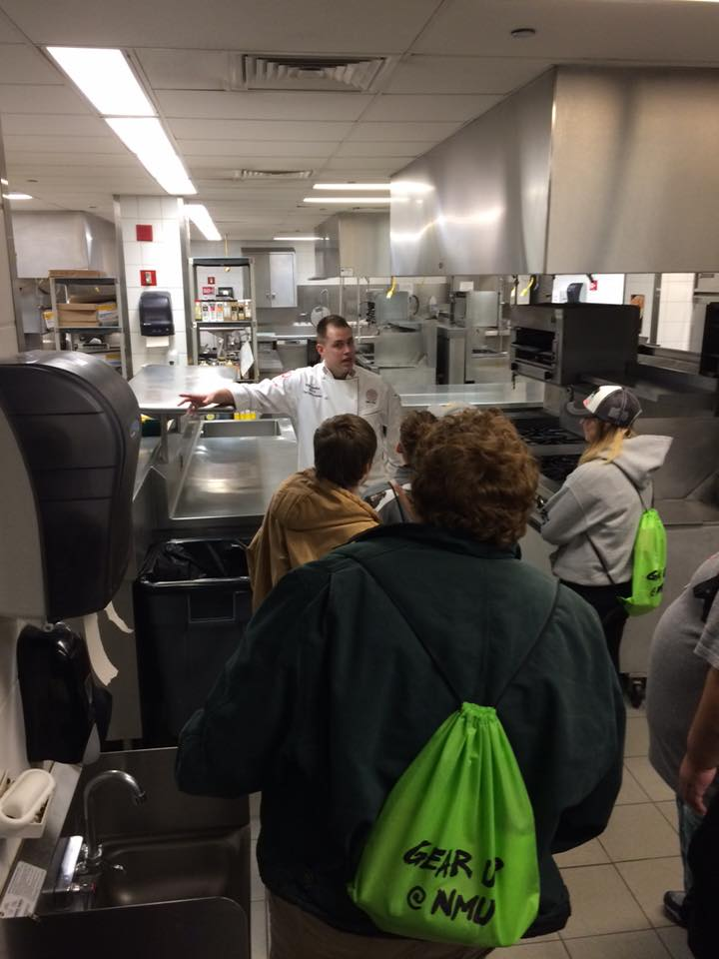

GEAR UP goes to Chicago

**Concussion Signs and Symptoms**

Concussions don’t only occur on the football field. Any mild to severe blow to the head can cause one, including hockey injuries, a shockwave (such as from an explosion), skiing/snowboarding accident, or falling and hitting your head. Although some injuries might not be too serious, others can be life threatening. Once you suffer from one concussion, it is easier for it to occur a second time. Each occurrence makes the next one that much more likely to happen.

Popular belief used to be that a concussion was no big deal. Injured people were told to just “shake it off and get back into the game.” Recent studies have proved this tactic to be wrong, and it could perhaps lead to even more serious situations. Elizabeth Quinn reports that a study found that of 2552 retired pro-football players, over 11 % of those with a history of multiple concussions also had a diagnosis of clinical depression. She continued, “Players reporting previous concussions were three times more likely to be diagnosed with depression than those with no history of concussion. “ <http://sportsmedicine.about.com/cs/head/a/concussion/htm?utm>

What you need to teach your teens about is how to handle themself if they receive a head injury and also what warning signs there are that they should look for. First of all, your child needs to stop playing and get medical attention. Even something relatively mild should be evaluated so that it doesn’t progress into something worse. Their brains need adequate time to heal.

All of the websites consulted list these as potential signs and symptoms of a concussion:

* Confusion or disorientation
* Memory loss
* Unconsciousness
* Unequal pupil sizes
* Headaches
* Dizziness
* Tinnitus
* Nausea
* Vomiting
* Vision changes
* Weakness in arms or legs
* Slurred speech
* Agitation or restlessness

Your teen may not experience all of these symptoms, but they may still have a concussion. Encourage them to wear a helmet, especially when skiing, snowboarding, skateboarding, or even riding a bike. Also, be sure to get them checked out by a doctor, if they suffer any type of blow to the head.

Other resources are available at

<http://firstaid.about.com/odconcussions/f/Concussions-Danger-Signs.html>

<http://sportsmedicine.about.com/od/headinjuries/a/Head/Injury>

**College Life 101**

Challenge your child to try something new. This could be tasting a new food in the cafeteria, joining a new club, or attending a religious service that sounds intriguing to them. There are a plethora of workshops, events, concerts, displays and lectures every week that your child can attend to learn more about the world around them. They may come back home with ideas different than the ones you raised them with, but they are learning about themselves and what is important to them as they become adults.

**Gardening in a 5-gallon bucket**

A productive vegetable garden can grow in containers, and it may have to if you have only a small space to dedicate to your food plot. A collection of 5-gallon buckets provides low-cost containers that are large enough to support most vegetables, especially if you only grow dwarf or patio varieties specifically hybridized for container growing. The buckets require some preparation before they can hold plants, and you should only use new buckets or buckets that previously held food-safe materials.

**1** Turn a 5-gallon bucket upside down. Drill four 1/2-inch-diameter holes in the bottom to provide drainage. Space the hole at equal distances apart.

**2** Mix equal parts peat, vermiculite and sterile soil together. Add 2 1/2 tablespoons of 14-14-14 fertilizer for each 5 gallons of soil and mix it in thoroughly. Fill the bucket to within 2 inches of the rim with the potting mix.

**3** Plant the vegetable seedling in the bucket at the same depth it was growing at previously. Set the bucket in an area that receives six or more hours of daily sun.

**4** Water the vegetables when the top 1 inch of soil begins to dry. Pour the water directly onto the soil at the base of the plant until it begins to drip out of the bottom drainage holes.

**5** Mix 1/2 tablespoon of a soluble 15-30-15 fertilizer with 1 gallon of water, or mix any soluble vegetable fertilizer at half the package-recommended rate. Water the vegetable with this solution every two weeks beginning at midseason or when the vegetable begins to flower.

<http://homeguides.sfgate.com/use-5gallon-bucket-grow-vegetables-73618.html>

**Illegal use of steroids**

There are legitimate uses for corticosteroids (commonly called steroids), such as treating rheumatoid arthritis, asthma, or severe allergic rhinitis, but all too often oral and injected steroids are abused. Generally, prescribed steroids are used for only a few days. Even then, they can cause temporary side-effects, including mood swings, insomnia, redness in your face, or increased appetite. If you experience other health issues, such as diabetes or high blood pressure, you need to be closely monitored by a trained medical professional, according to Dr. Daniel More, an allergies expert.

Of course, steroids are also being used illegally. They can be taken orally or injected directly into muscles. The most common use for “street” steroids is to bulk up muscles. The goal is to get those rock hard abs or bulging biceps. Some users have been known to use between 10-100 times higher doses than those prescribed by doctors, clearly abusing the drug. One typical scheme involves stacking, which is starting with a lower dose, then building to a crescendo, then tapering off again to the starting dose.

Neither way of using (abusing) steroids is effective and can cause more harm than good. Common side effects can include hair loss, increased acne, liver tumors, and clogged arteries in your heart. Guys can end up growing breasts, experience shrunken testicles and a reduced sperm count. Girls may grow beards, lose their breasts, or experience deepening voices. According to Wed MD, teens who abuse steroids before the typical adolescent growth spurt risk staying short and never reaching their full adult height. Doctors have reported that people can experience depression and may also suffer from an emotional imbalance. Eventually, steroids can cause mania, delusions, and violent aggression or “road rage.” So while your teen might look great on the outside, they could be seriously and irreparably harming their bodies inside.

Make sure that you are keeping an open dialogue with your teen. Dinner time discussions, or whenever you can be together with your child, are the best ways to bring up all kinds of issues. They still want to believe that they know it all, and we don’t know anything, but it is our responsibility to keep them safe.

Additional Information and direct quotations included here have come from:

<http://allergies.about.com/od/medicationinformation/a/stemicsteriod>

<http://www.webme.com/men/anabolic-steriods>

Other resources include:

<http://www.steriods.com>

<http://drugabuse.gov/publications/drugfacts/anabolic-steriods>

GEAR UP  
Multicultural Education & Resource Center  
3001 Hedgcock  
1401 Presque Isle  
Marquette, MI 49855  
1-906-227-1554  
This newsletter and past editions are available at:  
http://www.nmu.edu/multiculturaledandres/node/30  
GEAR UP Director Shirley Brozzo  
GEAR UP Student Coordinator Sara Spragg