

**Family Newsletter**

June 2015

**Looking for something to do this summer? Keep up with your reading. These books are on the suggested list for 11th grade students. I was amazed at the number of these books that I have NOT (yet) read. Enjoy!**

**Novels:**

|  |  |
| --- | --- |
| THE ADVENTURES OF HUCKLEBERRY FINN | Twain, Mark |
| AS I LAY DYING or  INTRUDER IN THE DUSK | Faulkner, William |
| COLD SASSY TREE | Burns, Olive Ann |
| FAHRENHEIT 451 | Bradbury, Ray |
| FALLEN ANGELS | Myers, Walter Dean |
| THE GREAT GATSBY | Fitzgerald, F. Scott |
| I KNOW WHY THE CAGED BIRD SINGS | Angelou, Maya |
| A LESSON BEFORE DYING  or A GATHERING OF OLD MEN | Gaines, Ernest J. |
| OF MICE AND MEN | Steinbeck, John |
| RANEY or WALKING ACROSS EGYPT | Edgerton, Clyde |
| THE SCARLET LETTER | Hawthorne, Nathaniel |
| THEIR EYES WERE WATCHING GOD | Hurston, Zora Neale |
| THE TURN OF THE SCREW | James, Henry |
| AIRFRAME | Crichton, Michael |
| ALL THE KING'S MEN | Warren, Robert Penn |
| THE AWAKENING | Copin, Kate |
| BELOVED | Morrison, Toni |
| BLACK BOY | Wright, Richard |
| THE BORNING ROOM | Fleischman, Paul |
| THE COLOR PURPLE | Walker, Alice |

|  |  |
| --- | --- |
| A CONFEDERATE WIDOW TELLS ALL | Gurganus, Allan |
| EAST OF EDEN | Steinbeck, John |
| ETHAN FROME | Wharton, Edith |
| A FAREWELL TO ARMS | Hemingway, Ernest |
| THE GRAPES OF WRATH | Steinbeck, John |
| THE HOUSE ON MANGO STREET | Cisneros, Sandra |
| THE ISLAND | Paulsen, Gary |
| JUBILEE | Walker, Margaret |
| THE JUNGLE | Sinclair, Upton |
| LAKOTA WOMAN (nonfiction) | Crowdog, Mary |
| KILLER ANGELS | Shaara, Michael |
| A MEMBER OF THE WEDDING | McCullers, Carson |
| MY ANTONIA | Cather, Willa |
| NATIVE SON | Wright, Richard |
| ONE WRITER'S BEGINNING (non-fiction) | Welty, Eudora |
| THE RED BADGE OF COURAGE | Crane, Stephen |
| A THIEF OF TIME | Hillerman, Tony |
| THINGS THEY CARRY | O'Brien |
| TRAIL OF TEARS: THE RISE AND FALL OF THE CHEROKEE NATION (non-fiction) | Ehle, John |
| THE WATER IS WIDE | Conroy, Pat |
| WHEN THE LEGENDS DIE | Borland, Hal |

**DRAMA**

|  |  |
| --- | --- |
| THE CRUCIBLE or DEATH OF A SALESMAN | Miller, Arthur |
| FENCES or THE PIANO LESSON | Wilson, August |
| THE GLASS MENAGERIE | Williams, Tennessee |
| OUR TOWN | Wilder, Thornton |
| THE NIGHT THOREAU SPENT IN JAIL | Lawrence, Jerome and Robert E. Lee |

<http://greenville.k12.sc.us/whhs/depts/media/11grRL.htm>

**Madison Media Institute**

If you're searching for a media school where you can receive hands on career training, look no further. We've got the equipment, facilities and industry professionals you need at MMI, the Madison or Minneapolis Media Institute. We offer programs* in a variety of media studies, designed for creative individuals looking to start a career path involving new media. At the Media Institute you can get the education you'll need to work in:

* graphic design
* web design
* music production
* audio recording
* game design
* animation
* video production
* talent management
* audio visual systems



**UW Madison**

The University of Wisconsin is a world-class university, nationally and internationally recognized for our academic excellence, incredible students, inspiring faculty, exceptional value, and an amazing campus and community. We invite you to learn more about UW–Madison and our academic programs, admission process, costs and financial aid, campus visits and more.

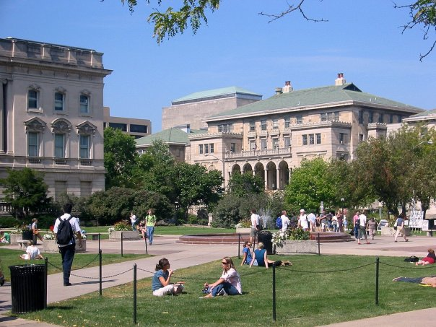

Oh, the Places You Will Go! GEAR UP Summer Camp 2015

There’s still time to get signed up for a FANTASTIC summer experience. Meredith has outdone herself in making this camp happen. Here are all the stops for this summer’s tour. Check it out:

**UW-Marinette**

Nestled in the beautiful pines along the shores of Lake Michigan, UW-Marinette is a beautiful place to visit. At UW-Marinette, you don't have to wait until you're a junior or senior to be Student Senate president, get the lead part in a play, or be a member of an athletic team. Classroom education may be a priority in your career, but your learning experiences don't stop there. Making time to become an active part of campus life will help you get the most out of your college experience. Freshmen and sophomores are the leaders at UW-Marinette. Future employers value the skills you will obtain through involvement in campus organizations and activities.

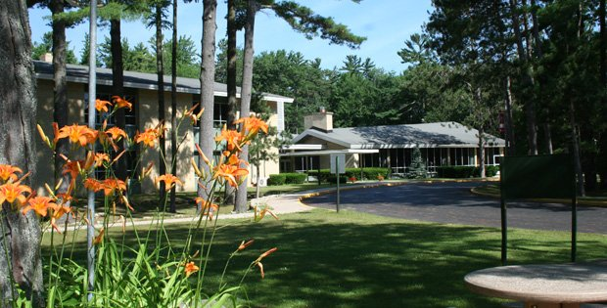

**UW-Green Bay**

The University of Wisconsin-Green Bay offers a wide array of undergraduate liberal arts and pre-professional programs and select master's level programs. UW-Green Bay emphasizes an interdisciplinary academic approach that offers opportunities for applied, hands-on learning, and stresses critical thinking and examining issues from multiple perspectives. By doing so, it prepares students for the jobs of today and tomorrow and also prepares students to become informed, active citizens. UW-Green Bay promotes the interchange of ideas between the University and community through internships and continuing education. The University encourages teaching excellence and innovation, community service, and racial and ethnic diversity.

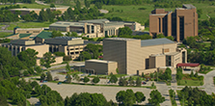

**Edgewood College**

As a Catholic college in the Dominican tradition, we are committed above all to the lifelong search for truth, pursued by men and women of all nationalities and backgrounds. All of us -- regardless of our personal spiritual beliefs -- are partners in the pursuit of a just and compassionate world.

For more than eighty years, we've put our students first in everything we do. We invite you to explore the College, and discover a place where students connect learning, beliefs and action.

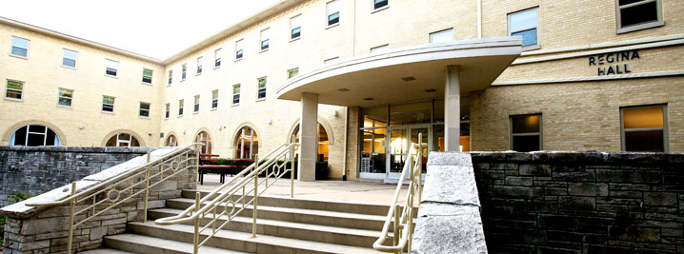

**Cave of the Mounds**

Cave of the Mounds takes its name from the Blue Mounds, two large hills which have long been Wisconsin landmark features. The West Mound, at 1716 feet, is the highest point in Southern Wisconsin; the East Mound reaches 1489 feet. Cave of the Mounds lies under the southern slope of the East Mound.



**Lambeau Field**

Champion’s Tour: Tour guides will lead you through the Lambeau Field Atrium, to one of our private suites. From there, you will go into our new South End Zone and see some of the spectacular updates made to Lambeau Field. From there, you will be taken down, through the players tunnel, and learn all about the incredible history of the Green Bay Packers. Feel the indomitable spirit and impassioned energy that makes the Packers and Lambeau Field so endearing. Outstanding photo opportunities avail themselves throughout each tour. This tour is approximately an hour and half in duration.



If your student hasn’t signed up yet, there is still time to get your application in. Applications are available in the school office, at [www.nmu.edu/gearup or by calling 906-227-1554](http://www.nmu.edu/gearup%20or%20by%20calling%20906-227-1554)

All information was taken from the main information page and all images are taken from [www.google.com](http://www.google.com)

You really need to become excellent label readers, looking not only for the word milk, but also for powered milk, whey , curds, or milk by-products. Chocolate also contains milk or milk products, so you need to watch the candies you buy, too.

More information can be found at [www.webmd.com/digestive-disorders/tc/lactose-intolerance-topic](http://www.webmd.com/digestive-disorders/tc/lactose-intolerance-topic) or [www.medicinenet.com/lactose_intolerance](http://www.medicinenet.com/lactose_intolerance)

As with any health concern, please consult your medical professionals for diagnosis and treatment.

**Enjoy your summer. Family newsletters will return again in September.**

**Possible Lactose Intolerance**

Has your child been complaining of feeling sick or having flu-like symptoms that don’t go away? Maybe it is from something they have been eating and/or drinking. There is a possibility of lactose intolerance.

A true intolerance for lactose, which means that your body cannot easily digest the natural sugars found in milk or dairy products, can make your life miserable. Common symptoms can include diarrhea, bloating, cramps, gas, and throwing up. Although anyone can experience these issues, lactose intolerance is most common in people of Native American, Asian, African, and South American descent. Generally, lactose intolerance runs in families.

Because people are so different, the effects of lactose intolerance may affect people differently. Some people are ok with ingesting small amounts of dairy products, some can have a moderate amount, and others can tolerate more. One reason for the difference in tolerance is also attributed to the amount of bacterial a person naturally possesses in their colons.

Yogurt seems to be one dairy product that is easier to digest, perhaps because of the bacteria it contains. These bacteria may help to break down the lactase. In addition to obvious dairy products to avoid such as milk and ice cream, there are many more foods that should be avoided including

* Bread
* Instant potatoes
* Soups
* Breakfast drinks
* Margarine
* Salad dressings
* Pre-mixed pancake, biscuit, or cookie batters

GEAR UP  
Multicultural Education & Resource Center  
3001 Hedgcock  
1401 Presque Isle  
Marquette, MI 49855  
1-906-227-1554  
This newsletter and past editions are available at:  
http://www.nmu.edu/multiculturaledandres/node/30  
GEAR UP Director Shirley Brozzo  
GEAR UP Student Coordinator Meredith Waara