

**Family Newsletter**

March 2017

1. Make a master grocery list on your computer from a spreadsheet or Word document. Categorize the groceries into sections such as frozen, dairy and so on. In each category, list the items you buy most frequently. Organize the grocery list according to the way your favorite grocery store's aisles are set up. Print copies and keep one handy for the current week. When you see you are low on a product or when you're preparing your grocery list for the week, simply highlight the items you need. Keep the document current by adding new items and/or deleting items you no longer buy. Create a space on the page for miscellaneous items where your family members can write down what they need that is not on your regular list.
2. Shopping the web beats hitting the brick-and-mortar stores, even for groceries. You'll avoid lines, traffic and lugging stuff home, and you can shop any time you like.
3. Create an inbox on your desk for papers (bills, permission slips, etc.) that need your attention. Clear it out daily.
4. Use one [power strip](http://www.amazon.com/Monster-Cable-MP-AV600-Protector/dp/B00003CWDG/sheknowscom03-20) (many can be mounted on a wall) as a home base for all of your rechargeable goodies: cellphones, cameras, music players, handheld video games, etc. You'll never have to hunt for an outlet or ask someone to call your phone to see where you left it.
5. Do you have a lot of visually indistinct items, such as chargers for electronic items? [Label them](http://www.amazon.com/gp/product/B000FHYZRW/sheknowscom03-20). You won't waste time looking for the right cord to charge the video camera, and when the scissors are left out on the table, you'll know who they belong to.

The goal of organizing isn't to make your home pristine, but rather to make your life more calm and functional. Work with the above ideas and you will end up with less clutter, a neater home, improved productivity and — most important of all — more quality time for yourself and your family.

All examples are from <http://www.sheknows.com/home-and-gardening/articles/6420/52-ideas-to-organize-your-home-an-organizing-tip-a-week/page:2>

**It’s Time for Spring Cleaning ☺**

There is no better time to tackle this huge project than in the spring of the year. You can enjoy a cleaner house while the kids are still in school and by the time they are out for the summer, these new routines should already be established. That will make your summer easier, since you won’t need to keep nagging the family members to pick up. These good habits should already be second nature to them.

1. Make sure everything in your house has a place. Teach all family members to mind their own messes. For example, if you take it out, put it back; if you open it, close it; if you throw it down, pick it up; if you make a mess, clean it up; and so on.
2. Put wastebaskets in every room and place several unused trash bags in the bottom of each one. This will eliminate countless trips to retrieve new trash bags and give all family members a place to throw away their trash.
3. Place a decorative basket on the coffee table in which to keep remote controls.
4. Use a plastic caddy (instead of shelf space) to store cleaning supplies, and simply tote it from room to room.
5. Keep baskets or tubs in every room for fast toy pickup. For kids' outdoor toys, purchase a weatherproof, bench-style storage box. Gather all outdoor balls and store them in the garage in a large, mesh drawstring bag.
6. Each night before bedtime, have all family members pick up clutter for 10 to 15 minutes. Make a game out of it and see who can pick up the most things in the shortest amount of time.
7. Create a family message center on the refrigerator or in another prominent place and use it for shopping lists, reminders, calendars and phone messages.

**The UP to DC College Tour** is set for March 26-31, 2017. Application deadline is March 20 at 5 pm. All hotels, food, and transportation costs are covered. There is NO CHARGE to participate. Your student will visit The University of Toledo, Georgetown University and Grand Valley State University as well as touring the monuments and several of the Smithsonian Museums in Washington, DC. We’d love to make this a true Senior Class Trip and have everyone attend.

Your students will be joined by a select group of students from Lake Superior State University’s GEAR UP program who have been regularly attending our trips, too. There will be five (5) chaperones along on the trip, including Adam Dompierre a current teacher from NSA; Meredith Waara, current Marquette teacher and former GEAR UP student coordinator; the current GEAR UP student coordinator, Abby Austin, the Graduate Assistant from the Multicultural Education and Resource Center, Ollie Mae; and college student Samantha Cole.

Below is more information about the schools your students will visit.

The University of Toledo is a metropolitan research university with 23,000 students

**The University of Toledo**

They offer more than 300 undergraduate, graduate and professional programs at colleges of:

* [Arts and Letters](http://www.utoledo.edu/al/index.html)
* [Business and Innovation](http://www.utoledo.edu/business/index.html)
* [Education](http://www.utoledo.edu/education/index.html)
* [Engineering](http://www.eng.utoledo.edu/)
* [Exploratory Studies](http://www.utoledo.edu/uc/undecided/index.html)
* [Graduate Studies](http://www.utoledo.edu/graduate/index.html)
* [Health and Human Services](http://www.utoledo.edu/hhs/index.html)
* [Honors](http://www.utoledo.edu/honors/index.html)
* [Law](http://www.utoledo.edu/law/)
* [Medicine and Life Sciences](http://www.utoledo.edu/med/)
* [Natural Sciences and Mathematics](http://www.utoledo.edu/nsm/)
* [Nursing](http://www.utoledo.edu/nursing/index.html)
* [Pharmacy and Pharmaceutical Sciences](http://www.utoledo.edu/pharmacy/)
* [University College](http://www.utoledo.edu/uc/index.html)

|  |
| --- |
| Main Campus features nine modern residence halls, a gothic bell tower, a [Student Recreation Center](http://www.utoledo.edu/studentaffairs/rec/index.html), and a state-of-the-art classroom center in one of our original buildings.  At UT, there are [researchers](http://www.utoledo.edu/research/index.html) working at all levels — from undergraduates to faculty — toward our mission of improving the human condition. In fact, their combined, efforts have led to 125 patents and nearly $60 million in funding and grants. Whether your interest is diabetes, performance management, bio-fuels, or Shakespeare, we welcome you to join us in research.  And our campuses are quite the happening (and fun) places to be — with 200 [student organizations](http://www.utoledo.edu/studentaffairs/osi/orglisting/), [art exhibits](http://www.utoledo.edu/al/svpa/art/index.html), [theater performances](http://www.utoledo.edu/al/svpa/theatrefilm/index.html), athletic games, and renowned speakers such as Robert F. Kennedy Jr and Toni Morrison.  UT proud of their Rockets (nickname) and love gold and blue (the school colors). |

Adapted from: <http://www.utoledo.edu/campus/about/>

Photo from Google Images

[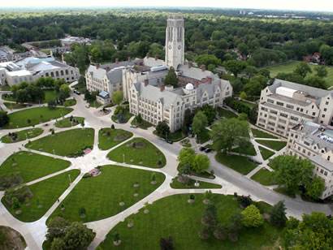](http://www.google.com/url?sa=i&rct=j&q=&esrc=s&source=images&cd=&cad=rja&uact=8&ved=0ahUKEwjy4Iv5yO_RAhWG3YMKHbrfAVAQjRwIBw&url=http://www.nse.org/exchange/campusprofile.asp?c%3D258&psig=AFQjCNGGbvSwQcZXGKbSlmHtHPv1d91Xcg&ust=1486061496625298)

**Georgetown University**

Georgetown University is [one of the world’s leading academic and research institutions](http://www.georgetown.edu/about), offering a unique educational experience that prepares the next generation of global citizens to lead and make a difference in the world. They are a vibrant community of exceptional students, faculty, alumni and professionals dedicated to real-world applications of our research, scholarship, faith and service.

Established in 1789, Georgetown is [the nation’s oldest Catholic and Jesuit university](http://www.georgetown.edu/about/history).  Drawing upon the [450-year-old legacy of Jesuit education](http://www.georgetown.edu/about/jesuit-and-catholic-heritage), they provide students with a world-class learning experience focused on educating the whole person through exposure to different faiths, cultures and beliefs. Students are challenged to engage in the world and become men and women in the service of others, especially the most vulnerable and disadvantaged members of the community.

Adapted from: <http://www.georgetown.edu/>

Photo from Google Images

[](https://www.google.com/url?sa=i&rct=j&q=&esrc=s&source=images&cd=&cad=rja&uact=8&ved=0ahUKEwiT0ZT_yu_RAhXoz4MKHdzHAVAQjRwIBw&url=https://www.theknot.com/us/hannah-liu-and-luke-mara-oct-2015&psig=AFQjCNF9scsLvejj8odNAsRDfaSpcflchg&ust=1486062038958957)

**Grand Valley State University**

**Established:** Grand Valley State University was chartered by the Michigan legislature in 1960 in response to the need for a public, four-year college in the state's second largest metropolitan region.

**Mission:** Educating students to shape their lives, their professions, and their societies. The university contributes to the enrichment of society through excellent teaching, active scholarship, and public service.

Current number of students: 25,460

Degree programs offered: 125

Average class size: 26

Nickname: Lakers

90% of student receive some type of financial aid

486 student organizations

8,275 students participating in internships, co-ops, practica, and student teaching

11,700+ employment and internship opportunities listed with GVSU Career Center

Photo and information adapted from: <http://www.gvsu.edu/about.htm>

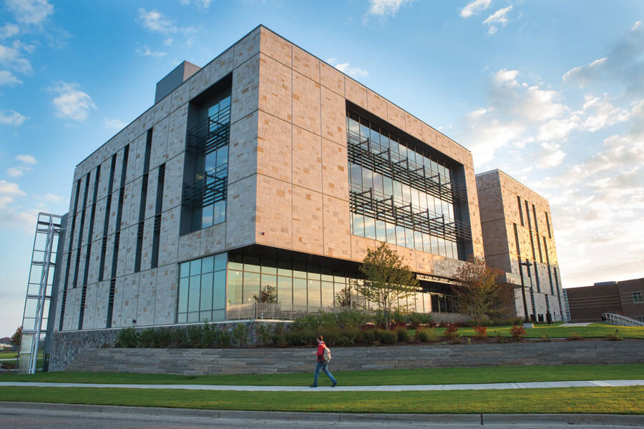

[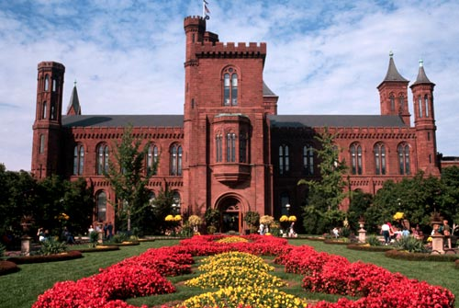](http://www.google.com/url?sa=i&rct=j&q=&esrc=s&source=images&cd=&cad=rja&uact=8&ved=0ahUKEwjn75a_zvHRAhWD2SYKHft3DnYQjRwIBw&url=http://www.nationalgeographic.com/walkingtours/Washington_DC_Walking_Tour/dct06.html&psig=AFQjCNF3FldVY4EMZyLYLWGbwIkR3UFMDw&ust=1486131785409571)

Smithsonian Castle

[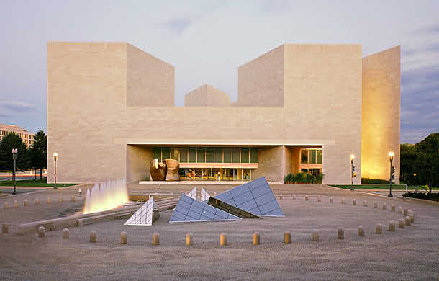](https://www.google.com/url?sa=i&rct=j&q=&esrc=s&source=images&cd=&cad=rja&uact=8&ved=0ahUKEwjP3oP6zvHRAhVE6CYKHV83DeEQjRwIBw&url=https://www.nga.gov/collection/20th_intro.shtm&psig=AFQjCNHngUcVZ-HsaJGCEr3OMg8VmlumrQ&ust=1486131902433131)

National Gallery of Art

[](http://www.google.com/url?sa=i&rct=j&q=&esrc=s&source=images&cd=&cad=rja&uact=8&ved=0ahUKEwiD1arZz_HRAhWISCYKHZRsAmkQjRwIBw&url=http://www.airlinereporter.com/2015/05/visiting-the-smithsonian-air-space-udvar-hazy-museum-at-dulles-airport/&psig=AFQjCNHCX_w99Xup-sNWFuMXb_YpAwgJmw&ust=1486132109852598)

Smithsonian Air and Space Museum

All images from Google Images

**Oh the Places They Will See while going from the UP to DC!**

[](https://www.google.com/url?sa=i&rct=j&q=&esrc=s&source=images&cd=&cad=rja&uact=8&ved=0ahUKEwiH8NnhzfHRAhWB6SYKHbVBDmIQjRwIBw&url=https://www.nps.gov/wamo/learn/historyculture/&psig=AFQjCNE7-LGyiNK24kHxtRUeDno1qrMYtg&ust=1486131585848869)

Washington Monument

[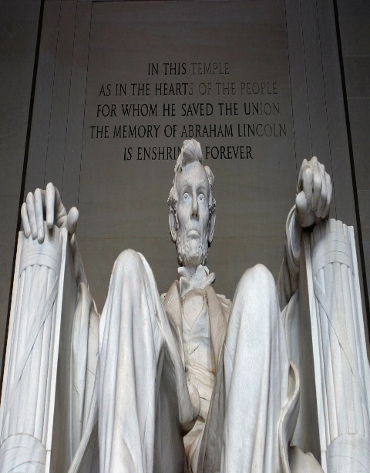](https://www.google.com/url?sa=i&rct=j&q=&esrc=s&source=images&cd=&cad=rja&uact=8&ved=0ahUKEwj9nL32zfHRAhUF5SYKHVf8ChgQjRwIBw&url=https://www.npca.org/parks/lincoln-memorial-national-memorial&psig=AFQjCNHUBAptW5QTtcpf25nnoppq6vvrKA&ust=1486131630930892)

Lincoln Memorial

[](http://www.google.com/url?sa=i&rct=j&q=&esrc=s&source=images&cd=&cad=rja&uact=8&ved=0ahUKEwikp_iRzvHRAhWDSyYKHTr0CwEQjRwIBw&url=http://learningenglish.voanews.com/a/hallowed-ground-arlington-national-cemetery/2780835.html&psig=AFQjCNFhpXA0Zs67PI88ENcufyyP1QFxpQ&ust=1486131691238833)

Arlington National Cemetery

GEAR UP  
Multicultural Education & Resource Center  
3001 Hedgcock  
1401 Presque Isle  
Marquette, MI 49855  
1-906-227-1554  
This newsletter and past editions are available at:  
http://www.nmu.edu/multiculturaledandres/node/30  
GEAR UP Director Shirley Brozzo  
GEAR UP Student Coordinator