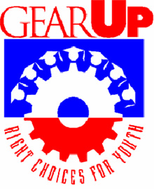

**Family Newsletter**

May 2015

**When thinking about how to answer: “What is your weakness(es)?**

Assessing Your Weaknesses:

This is probably the most dreaded part of the question. Everyone has weaknesses, but who wants to admit to them, especially in an interview?

The best way to handle this question is to minimize the trait and emphasize the positive. Select a trait and come up with a solution to overcome your weakness. Stay away from personal qualities and concentrate more on professional traits. For example: "I pride myself on being a 'big-picture' guy. I have to admit I sometimes miss small details, but I always make sure I have someone who is detail-oriented on my team."

**This information was taken from the Career Advice tab on** [**www.Monster.com**](http://www.Monster.com) **(a career website)**

* Talk about how you were able to turn one of your negative traits to something positive, also talk about how you have improved on it.
* It is not favorable to hire someone who says that don’t have a weakness or don’t know it. Everyone has a weakness, and it is important that people learn from them.

**It will be summer vacation before we know it and many of your students will be looking for that summer job, if they don’t already have one. It never hurts to be prepared. GEAR UP knows that the hardest questions to answer are “What are your strengths? and “What are your weaknesses?” Here are some examples compiled by NMU student Sara Spragg.**

**When thinking about how to answer: “What is your strength(s)?**

Assessing Your Strengths:

Assess your skills, and you will identify your strengths. This is an exercise worth doing before any interview. Make a list of your skills, dividing them into three categories:

Knowledge-Based Skills: Acquired from education and experience (e.g., computer skills, languages, degrees, training and technical ability).

Transferable Skills: Your portable skills that you take from job to job (e.g., communication and people skills, analytical problem solving and planning skills)

Personal Traits: Your unique qualities (e.g., dependable, flexible, friendly, hardworking, expressive, formal, punctual and being a team player).

** When you complete this list, choose three to five of those strengths that match what the employer is seeking in the job posting. Make sure you can give specific examples to demonstrate why you say that is your strength if probed further.

**Apply for lots of jobs.** Don’t wait until you hear back from on application before you submit another one. Make sure your cover letter is tailored for each individual position. You may get more than one offer, and that would be wonderful.

**Keep your options open.** In other words, be flexible on the type of job you will take and your hours of availability. It may not be your dream job to work in McDonalds, but it is a great first job. You will learn valuable skills like being on time, working as a team, following rules and procedures, customer service, and how to keep things neat and organized. Those are skills that are transferrable to any job.

**Dress Accordingly.** When you get an interview (and when you get the job), make sure you are wearing clean, hole-free clothes. As they say, use the “Grandma rule” – if your grandmother would like your interview outfit, you are dressed properly.

**Finding that summer job.**

Breaking into the job market can be hard for your teen, especially if this is their first position. Here are a few tips that might help them out. Feel free to use them yourself if you are searching for a new or different job.

**Don’t be afraid to put yourself out there**. Make sure your friends and family know that you are looking, because they may know of positions that haven’t been advertised. Networking is a great way to find work.

**Remember to look in your own back yard.** Are there jobs in your neighborhood that you could do? Babysitting? Dog walking? Mowing the lawn? In addition to earning money, you will be increasing your network of people who can become a reference for you.

**Make sure you know the rules.** Does the job require you to have a work permit? According to <https://www.michigan.gov/mde/0,4615,7-140-6530_2629_59590_,00.html> Youth Employment Standards Act 90 of 1978 defines a minor who is less than 18 years of age, including but not limited to employees, volunteers, independent contractors, and performing artists.

Minors under 18 years of age must obtain a work permit or a written agreement or contract entered into between the employer and the governing school district, public school academy, or nonpublic before starting working. Work permits can be obtained from the issuing school officer (the chief administrator of a school district, intermediate school district, etc.) the minor attends or the school district where the minor will be employed. If the minor changes jobs, a new work permit is required for the new employer. A work permit may be revoked for poor academic performance. A work permit is required even if the minor is home/cyber/virtual/online schooled, does not attend school, or out-of-state resident.

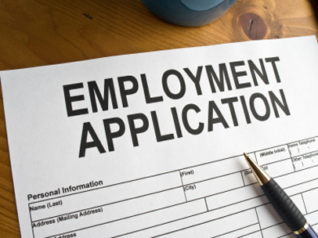

How to have a successful interview

Once you get called for an interview, you need to be prepared for it. Make sure you have done some homework on the company/business you are planning to work for. It will not look good for you if the first questions you ask is what they do there!

A few other general suggestions are:

* Don’t be late. In fact, you should arrive early.
* Don’t answer your phone. (It should be off)
* Don’t chew gum.
* No swearing!

As you are being interviewed, do NOT say things like:

* I hate my job.
* My boss is the worst boss ever
* The place I work now sucks

These statements make the interviewer wonder what you would say about them/their company if you are dissatisfied.

DON’T ask:

* How much will I make?
* When can I take vacations?
* Can I date co-workers?
* Can I work from home?

These questions could wait until you are offered the job. And this is not a dating service.

And some final tips. Don’t say:

* I don’t have a car yet, but I am getting one. (Will you be reliable?)
* I really need this job. (Sounds desperate)
* Interviews make me so nervous. (They want someone confident)
* I don’t have any questions. (You should always have questions. See the next section)



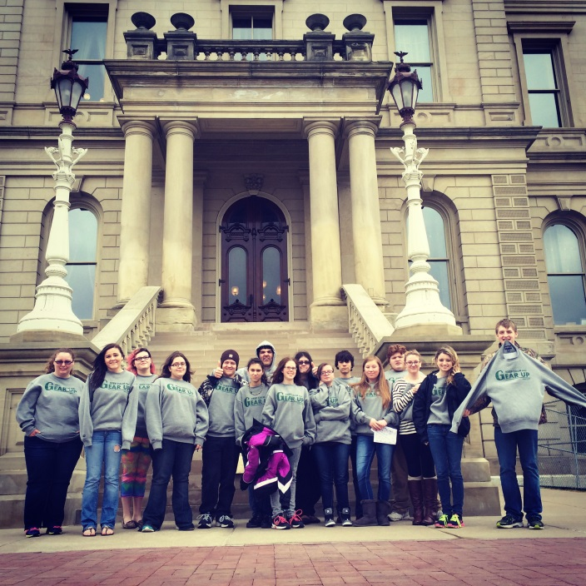

GEAR UP  
Multicultural Education & Resource Center  
3001 Hedgcock  
1401 Presque Isle  
Marquette, MI 49855  
1-906-227-1554  
This newsletter and past editions are available at:  
http://www.nmu.edu/multiculturaledandres/node/30  
GEAR UP Director Shirley Brozzo  
GEAR UP Student Coordinator Meredith Waara

**GEAR UP Summer Camp is June 21- 27, 2015!**

You can now access summer camp applications on line at [www.nmu.edu/gearup](http://www.nmu.edu/gearup) and paper copies will be available soon in the office.

For the first time, this summer GEAR UP will be traveling to Wisconsin to see a few of the schools there. They offer great and unique opportunities for higher education. Please check with individual schools to see if you are eligible for in-state tuition or if you will be paying the higher out-of-state amount.

Camp will start on Sunday, June 21 with activities on campus until Wednesday morning, June 24. We expect other students to join us from other GEAR UP programs affiliated with Lake Superior State University (LSSU) and with Michigan Technological University (Tech). Then on Wednesday we will take off via motor coach. Tentative plans include UW-Marinette, UW-Madison, and UW-Green Bay. We are also currently in negotiations with representatives at Lambeau Field to be able to provide a behind-the-scenes tour and career discussions. Your students might not know that there are many jobs besides being a football player, cheerleader, or coach. There are also athletic trainers, sports promoters, sales/ticket managers, and many more career opportunities.

Below is a picture of the Spring Break tour of the students at the state capital in Lansing.

How to end the interview

At the end of every interview the interviewer will ask you if you have any questions for them. It’s always good to be prepared with at least a few questions. If you don’t you may come across as not really interested in the job or as being unprepared for the interview.

You can ask about:

* Responsibilities of the job
* What is a typical day like?
* Will I have a mentor?
* What is the company management style?
* What do you like about working here?
* Is there room for advancement?

Some things NOT to ask include:

* Did I get the job?
* What does the company do? (Do your homework before the interview)
* Are their office/company parties?
* Are there benefits? (If you are offered the job, that’s when you ask.)

Hopefully you are now a little better prepared for your interview. For more information you may also want to check out [www.Monster.com](http://www.Monster.com) , [www.careeerbuilder.com](http://www.careeerbuilder.com) , or [www.snagajob.com](http://www.snagajob.com)