PARENT NEWSLETTER
January 2014

Sean Covey has much to say about the 7 Habits of Highly Effective Teens. You can help your child become more effective by helping them prepare for adulthood. Covey’s third habit is on putting first things first. In other words, are you helping them to set priorities? Below are a few ideas, paraphrased from Covey’s 1998 book. They may be helpful to both your student and you.
- Use a planner
Did you know that GEAR UP provided your student with an academic planner at the beginning of the year? Is your child using the planner to keep track of assignments, research papers, team sports, or other important information?
- Identify and avoid time wasters
Help you student realize they don’t need to spend hours at a time on the phone, playing video games, surfing the net or watching reruns on TV.
- Teach them it’s ok to say no
They don’t have to be a “people pleaser” and say yes to every request that they get.
- Help them learn to overcome a fear that is holding them back from reaching a goal
Help them to step outside their comfort zone and try something new. They might even find that they like doing something new or trying new things.
- Talk to them about peer pressure
Your student needs to know you are there and you care about what is happening in their lives Make sure you know who their friends are and what types of things they do when they hang out together. If the friends are a good influence, like in working together to shovel out an elder neighbor, then that should be reinforced. However, if the friends are influencing your child to spray paint graffiti on a wall, something your child wouldn’t do without being pressured, then they need to know you are there for them.
What if your child tells you they are gay, lesbian, bisexual or transgender (GLBT)?

Some of you may react in ways that will hurt your child, such as crying, getting angry or feeling embarrassed. You may ask what you “did wrong” to “cause this.” This isn’t about you. This is about your child. You haven’t done anything wrong, nor are you the cause of your child’s feeling.
Some of you may feel honored and appreciate that your child felt comfortable enough to tell you such an important truth about themselves. You might have already known this about your student, or suspected that they might be GLBT. Perhaps you were just waiting for them to realize it themselves.
Some of you will need to grieve the dreams you had for them before you can embrace the new dreams they will be creating.
Perhaps some of you grew up in a time when some of the stereotypes about GLBT people were more prevalent than they are today. Or perhaps you believe being gay is a sin or that therapy can change your child.
If your child is GLBT, they are still the same person they were just minutes before they came out to you. Please help them continue to grow into successful adults. What your child wants from you is the same love and support that you have always provided them.

You may not have all the answers to your child’s questions, but there are plenty of resources available. Here is a short list of resources, however many more are available in your community and on-line.
An Ally’s Guide to Lesbian, Gay, Bisexual and Transgender Americans
www.hrc.org/resources/entry/straight-guide-to-lgbt-americans
Transgender Visibility: A Guide to Being You
www.hrc.org/resources/entry/transgender-visibility-guide
Human Rights Campaign www.hrc.org
Parents, Families and Friends of Lesbians and Gays (PFLAG) www.pflag.org
Information paraphrased from www.hrc.org/comingout
It’s Winter: Are You Getting Enough Exercise?
Many parents and students don’t realize that when the wind and blizzards begin, the motivation for physical activity ends. As difficult as it is to want to get outside in the Upper Peninsula’s frigid weather, staying active is an important and necessary part of participating in a healthy lifestyle. In the Marquette area, there are many different opportunities for physical activity. While some may cost a bit of money (but are a great investment!) there are many options that are free and open for everyone to use.
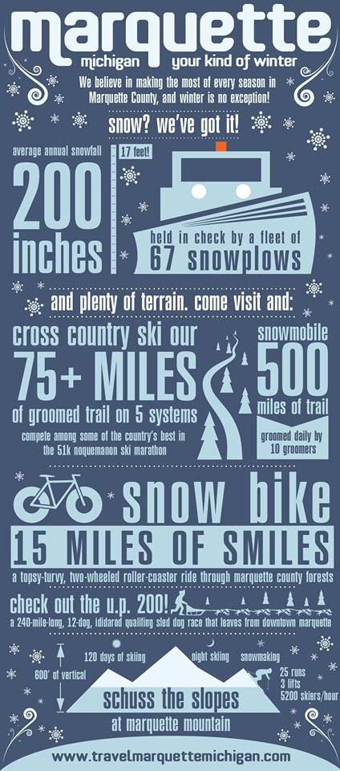
- NMU’s Physical Education and Instructional Facility (PEIF). Visit http://www.nmu.edu/sportsrecsports/ for more information.
- NMU’s Berry Events Center offers skating and weight lifting facilities. Visit http://www.nmu.edu/sportsrecsports/node/118 for more information.
- There are numerous walking, biking, and other recreational opportunities available around Marquette. Check out this map for ideas! http://mqtcty.org/documents/City_of_Marquette_Recreation_Map_071613.pdf
- If you have a dog, take them for a walk or a jog. Getting out in the cold wakes you up and you feel great when you go back in to a warm house! Your dog will thank you as well.
- Shovel the driveway. Your arm muscles will get a great workout with all the heavy snow we are sure to get. Blowing snow with the snow blower is also good exercise.
- Video games are not usually a good idea when promoting physical activity, but if your family has the opportunity to play a Wii Fit game or an interactive Wii game, play! Even Wii Bowling has its benefits in the long run.
- Getting involved in a sports team or afterschool activity is almost always an option for students, but check with the school if they have opportunities for parents to get involved too!
- Families with active parents or guardians are more likely to have children and teens that are physically active. By promoting a healthy lifestyle at home, students are more likely to make healthy choices elsewhere.
Spring Break Campus Visits
GEAR UP is planning a campus visit bus trip for your student’s spring break, March 31 to April 4. We will be visiting several colleges and universities down state. More information will be forthcoming. GEAR UP will pay for hotels, meals, and transportation. Your student may want some spending money, but all necessary expenses will be covered.

College Goal Sunday is February 9
If you have a student who is a Senior and getting ready for college, here’s some help for you. You need to submit the Free Application for Federal Student Aid (FAFSA). To get the most assistance for college and your application needs to be turned in by March 1. You can get free assistance at:

YMCA of Marquette County
1420 Fair Ave
Marquette, MI 49855
Website: www.ymcamqt.org

NMU Celebrates Martin Luther King Jr.’s Birthday
Come and hear Reverend Doctor Jamie Washington speak about Diversity and Social Justice. Get his impressions of the civil rights movement and how it relates to today. Thursday, January 23rd at 7 pm in the Marquette/Nicolet Rooms of the University Center
.

