|  |  |  |
| --- | --- | --- |
| **GEAR UP**  **Monthly Update** | |  |
| January 2020 |
|  | | |
| Welcome to 2020 everyone! It is hard to believe that we flew through 2019 as quickly as we did. However, now it is time to charge forward. Our learners are just about half way through the school year with so much learning to come. This break was important not only to celebrate with each other but also to give our learners the rest they needed to refocus and hit the ground with great strides forward for the second half of the year.  These coming months will include some exciting programming activities that your learner will be able to partake in, this month especially. While in class, your students will have a chance to work with robots that will be rented from the Seaborg Center on campus at Northern Michigan University. As part of the GEAR UP program we try to give learners access to STEM related materials and display some of the exciting opportunities available in STEM fields.  I want to take this opportunity to thank everyone for a great first semester and share with you how excited I am to continue working with these learners. I have had such a great time so far in this position and cannot wait to see what else we can do as a class!  Have a wonderful month!  -Anthony A Note from YourStudent Coordinator By Anthony Rospierski | | |
| “If you knew they could have learned anything, what would you wish you would have taught them?”  -Dr. Paula Kluth  INSIDE THIS UPDATE   1. Student Coordinator Update 2. The Reality of SAD 3. Resources to Help Pay for College 4. Concussions: The Serious Invisible Injury |  | |

## Page 2

|  |  |
| --- | --- |
| The Realities of Seasonal Affective Disorder By Anthony Rospierski  Seasonal Affective Disorder (SAD) is commonly referred to as the winter blues. However, SAD is a real diagnosis that can contribute to depression symptoms. While it is normal to have days where you feel down, having weeklong stretches of not wanting to get out of bed and not participating in activities is a sign of depression.  https://tinyurl.com/y8ftwby7  Summer SAD and Winter SAD have differing symptoms specific to each season. Winter SAD can contribute to weight gain, an increase in in tiredness and decrease in energy and appetite changes, typically causing cravings for high carb foods. It is important to remember that feelings related to SAD and all mental health issues are normal. Shame associated with mental illness is misplaced and contributes further, often times, to people experiencing mental health issues.  The causes of SAD are contributed to your biological clock, serotonin levels, and melatonin levels. The reduced level of sunlight during the winter months often times | cause SAD and can be negated through light therapy lamps and even therapy sessions with a clinical psychologist.  https://tinyurl.com/y8ftwby7  The following are signs and symptoms related to SAD. If you are anyone you know struggles with mental illness please reach out to mental health service providers.  -Feeling depressed most of the day, nearly  every day  -Losing interest in activities you once enjoyed  -Having low energy  -Having problems with sleeping  -Experiencing changes in your appetite  -Feeling sluggish or agitated  -Feeling hopeless, worthless or guilty  -Having frequent thoughts of death or suicide  “It is important to remember that feelings related to SAD and all mental health issues are normal.”  -Mayo Clinic |
|  | |
|  | |

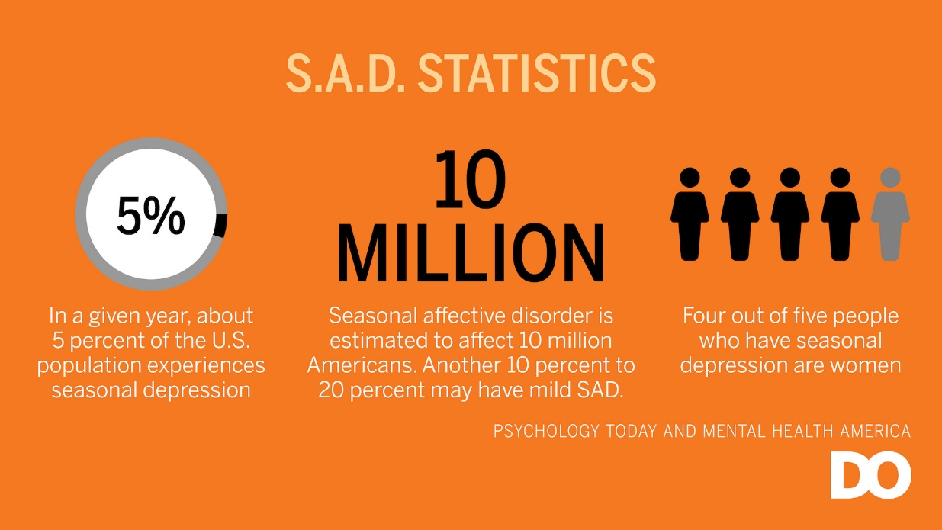

GEAR UP

Monthly Update

|  |  |
| --- | --- |
| Is it too early to Start Thinking about College? By Anthony Rospierski  One of the things that I wish my parents would have been able to help me with was saving my own money for college. Even if it is not the direct costs of attending school but rather the indirect costs such as gas, groceries, and supplies for my first place away from home. Some of the things that I took for granted such as always having aspirin for when I had headaches suddenly became large costs to stock up in my own place.  The transition from high school to college is sometimes daunting so finding ways to earn; and winning scholarships or grants, and knowing how to apply for the FAFSA is essential early on in your quest for post-secondary education. What I found out on my own was that if I can earn scholarships and grants then any money that I earn through work becomes spending money.  Going into high school is the time when I started working in the community. I found work at a local ice cream store earning minimum wage, but because I didn’t have any living costs I was able to save all of the money I earned. Granted I spent the majority of it on non-necessities!  What I wish my parents would have told me to do | “Make a goal of saving $1,000 per summer to take with you to college. If your student can work just 20 hours at the current minimum wage, they can earn upwards of $3,000 every summer.”  however, was to make a goal of saving at least $1,000 per summer to take with me to college. If your student can work just 20 hours a week over the summer earning the current minimum wage they can earn upwards of $3,000. I think putting away just a third of that $3,00 is achievable each summer. Now, multiply that by four summers before going to college and your student has a good chunk of change going into their first year away from home.  To find more ways to pay for the first year at college you can visit payingforcollegeresources.com. Sallie Mae is a nationwide student loan lender that sponsors this website. There is information on the basics of financial aid and what you need to know about student loans. It is never too early to start the conversation. Think early and think BIG! |
|  |

GEAR UP

Monthly Update

## Page 3

GEAR UP

Monthly Update

## Page 4

|  |  |  |
| --- | --- | --- |
| By Linda Sioris  “Did you get knocked out?” This used to be the million-dollar question posed to kids injured at play. Whether knocked in the head with a baseball bat, trampled in tackle football, or thrown from a bicycle, the medical decision tree branched in two very different directions from that simple question.  If the child answered “No,” then the injury was cleaned, maybe stitched up, and they were sent on their way; if “Yes,” then they were examined more closely. Still, most of us parented with the assumption that children are going to take hard knocks and if they are up and moving then they must be okay, right? Wrong. According to the Brain Injury Association of Michigan (BIAMI), every 21 seconds a person in our country sustains a traumatic brain injury, or TBI, which is defined as an insult to the brain that occurs from an external force and results in some level of impairment of, or disturbance to, cognitive, physical, emotional, or behavioral functioning. The impairment may be mild or severe.  Researchers have learned that kid’s brains are particularly vulnerable—especially from repeated blows such as those sustained in organized sports. “The risk of TBI is highest among adolescents, young adults, and those over 75; TBI is the leading cause of death and disability among youth and young adults” (biami.org).  The definition of a TBI is frighteningly broad with symptoms that sound difficult to pin down, |  | especially for the milder injuries. Children and adolescents can have a wide range of “normal” behaviors, as parents well know.  “It’s hard to take seriously an invisible injury with subtle symptoms that often seem to pass quickly,” write Linda Carroll and David Rosner, in the book *The Concussion Crisis: Anatomy of a Silent Epidemic*. To complicate matters, brain injury, especially in the young, is cumulative: after the first injury, the risk for a second injury is three times greater; after the second injury the risk of another TBI is eight times greater (biami.org). In the past decade, brain injury researchers have determined that concussion can, and often does,occur *without any loss of consciousness* or even without a child sustaining a direct blow to the head.  Parents and caregivers are the best people to determine any changes in their child’s normal behavior or functioning—which may appear days or even weeks after an injury to the brain. Be aware, watch closely, and educate yourself about brain injury through reputable sources. (biami.org) Be persistent in advocating for safety equipment, medical intercession, and trust your parental instincts when it comes to your child. You know them better than anyone does. |

# Concussions: The Serious Invisible Injury

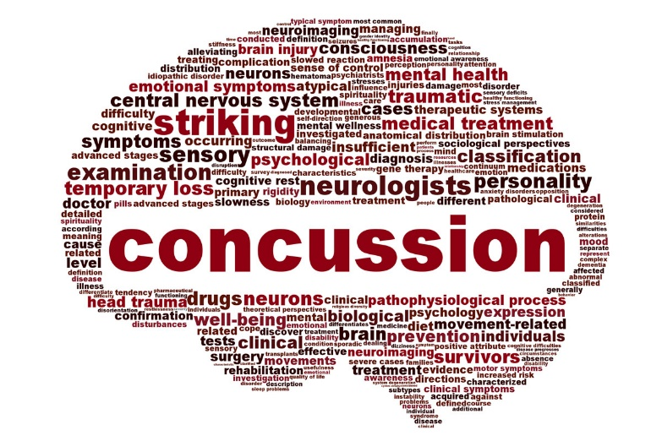

Multicultural Education and Resource Center

GEAR UP

3001 Hedgcock

Northern Michigan University

Marquette, MI 49855