|  |  |  |
| --- | --- | --- |
| **GEAR UP**  **Monthly Update** | |  |
| June 2019 |
|  | | |
| Greetings and salutations! My name is Anthony Rospierski, a senior Special Education major, from Midland, MI. I started working at the Multicultural Education and Resource Center as the GEAR UP Student Coordinator at the end of the 2018-2019 academic school year. While I am sure many are sad to see the previous Student Coordinator, Liz, graduate I want to wish her well as she begins her new journey.  When I decided to move to Marquette following high school I knew that my life was going to change quite a bit. I am excited to participate in a program designed to help students transition from secondary education towards post-secondary success! My first year at Northern Michigan University entailed ROTC, education courses, volunteer work at the YMCA and the Family and Youth Center at Superior Village.  Before working for the MERC, I worked with Teaching Family Homes to assist local UP families in crisis. While I do bring experience to my new role, I am a firm believer in how self-reflection and feedback benefits individuals and organizations. My hope is that students and family supporters feel welcomed in the MERC office with an open door policy to bring concerns or fresh ideas to the attention of myself or Associate Director of the MERC, Shirley Brozzo.  Continue to read further on the back spread… Greeting from your newStudent Coordinator By Anthony Rospierski | | |
| INSIDE THIS UPDATE   1. Meet the new Student Coordinator 2. The Importance of Summer Reading 3. Summer Activities to Stay Busy 4. Summer Reading List   “If you knew they could have learned anything, what would you wish you would have taught them?”  -Dr. Paula Kluth |  | |

GEAR UP

Monthly Update

|  |  |
| --- | --- |
| For students summer reading is crucial to success for the year to come. Reading throughout the summer has benefits that expand beyond maintaining reading level. While reports show when students read infrequently or not at all during the summer months, their reading abilities decrease, under preparing them for the following year. Reports also suggest that reading different books build stronger and more culturally aware students when reading texts that are diverse in nature. Mirrors, windows and sliding glass doors is an example of creating a culturally aware reading list. The “mirrors” of the book list reflect the culture and area in which the reader lives. “Windows” allow readers to explore cultures and places unfamiliar to them for becoming aware. Finally, “sliding glass door” texts are a true emersion into a culture a part from your own. Becoming a more culturally responsible individual can help students create more friends and expand their personal knowledge.  Here are four ways to help keep your children reading:   1. Encourage your children to read books they enjoy for at least 30 minutes per day. Your child will likely be more engrossed in material they choose themselves than material that is forced on them. 2. Provide incentives for reluctant readers. If your child enjoys playing basketball, agree to take them to the local courts if they do their “daily reading.” 3. Make reading family time. Establish a time during the day that every member of the household is reading. 4. Make connections to the readings. If you plan on going on a vacation, pick up a new book about that place!   https://blog.ed.gov/2011/08/why-summer-reading-pays-off-year-round/ The Importance of Summer Reading for Young Minds By Anthony Rospierski | “Becoming a more culturally responsible individual can help students create more friends and expand their personal knowledge.” |
|  | |
|  | |

## Page 2

GEAR UP

Monthly Update

## Page 3

# What to do this Summer in Marquette

Are you interested in staying active this summer but do not know where to start? As part of the GEAR UP program we want you to stay active this summer and have as much of an opportunity to stay healthy while receiving the services your family unit might need. Included in this monthly update is a list of activities and services provided to you in the local Marquette community. If you need to find out more about the information that you see here or about other possible events tailored to your needs reach out to us at the MERC at (906) 227-1554. You can also drop into the office located on the second floor of the Hedgecock student services building on the campus of Northern Michigan University between the hours of 7:30 AM and 4:00 PM.



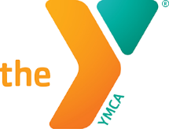

The YMCA of Marquette is an incredible opportunity for children to get out this summer and stay physically active. There are two options for joining with the YMCA, individual youth day passes are $6 and the individual youth monthly passes are $22 per month. Throughout the winter months, donors work with the YMCA to provide scholarships to help afford youth, family, or individual memberships at no cost. If you would like to learn more about what the YMCA has to offer, reach out to them at (906) 227-9622.

The Guardians of WOW, run through the Upper Peninsula Children’s Museum, is an independent volunteer program where children age 8-18 are able to help around the museum. Only one training is needed, offered the first Friday of every month from 4:00 pm- 6:00 pm and one caregiver meeting from 5:30 pm- 6:00pm on the same day. After their initial training and meeting, your student is free to come in during operational hours and volunteer at their leisure.





## Page 4

GEAR UP

Monthly Update

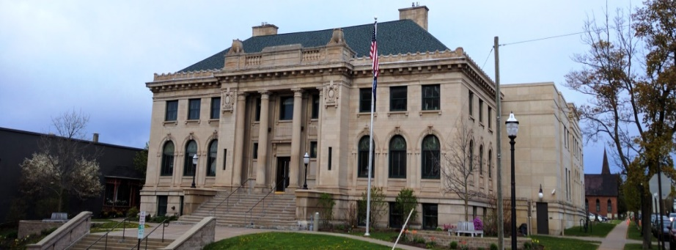

**Warriors Clan War Capture the Flag: June 19th**

Peter White Public Library (PWPL) sponsored event. Come join PWPL at Lower Harbor to play capture the flag, event time runs from 7:00 pm- 9:00 pm! Great event for middle school age children!

# Events in the Neighborhood

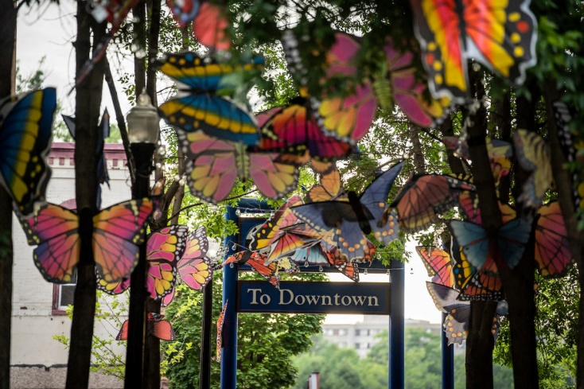

**ART WEEK: June 24th-29th**

Marquette City will present its fifth annual Art Week. Located downtown this year local artists, art organizations, and businesses will come together to create a weeklong event of concerts, workshops performances and demonstrations. For more information visit Travel Marquette’s website at travelmarquettemichigan.com



**Feeding America of West Michigan Mobile Food Pantry: June 21st**

Feeding America’s mobile food pantry will be in town at the Lakeview Arena on Friday, June 21. In addition to the mobile food pantry, other food distribution centers include Salvation Army of Marquette, and Child and Family Services UP located in Chippewa Square. To find open hours visit feedwm.org/findfood



**Fourth of July Celebration and International Food Festival: July 3-5**

Join the Marquette Community as they celebrate the 4th of July and great food during the first week of July. On the 4th Lower Harbor is the place to be to see the best firework display in the Upper Peninsula!

# Summer 2019 Reading List

By Anthony Rospierski

|  |  |
| --- | --- |
| *Code Name Verity* is the story of a friendship formed between two young women, Julie Beaufort-Stuart and Maddie Brodatt, during the early years of World War II. When the story opens, it's November 1943, and Julie is a prisoner of the Nazi Gestapo in Ormaie, a city in Nazi-occupied France.  Alone at home, twelve-year-old Grayson Sender glows immersed in beautiful thoughts and dreams. However, at school, Grayson grasps at shadows, determined to fly under the radar. Because Grayson has been holding onto a secret for what seems like forever: “he” is a girl on the inside, stuck in the wrong gender’s body  Emily has always been the kind of girl who tries to do the right thing- until one night when she does the worst thing possible. She sees Belinda, a classmate with developmental disabilities, being attacked. Inexplicably, she does nothing at all. *A Step Toward Falling* challenges readers thoughts about who they see themselves as in this Cammie McGovern young adult novel.  Ender Wiggin, a brilliant child prodigy, is Earth’s last hope of defeating an insect-like alien race called the Buggers. Colonial Hyrum Graff of the International Fleet convinces Ender to enroll in Battle School after an incident in which Ender accidentally kills a bully named Stilson, in self-defense. In Battle School Ender is purposely isolated from his fellow students in order to make him a more effective military leader.  Fantasy becomes reality in an exploration of mental illness based partly on the experiences of the author's son, who is also the book's illustrator. For 14-year-old Caden Bosch, his gradual descent into schizophrenia is a quest to reach the bottom of *Challenger Deep*, the deepest place on Earth. |  |
|  |

GEAR UP

Monthly Update

## Page 5

GEAR UP

Monthly Update

## Page 6

|  |  |  |
| --- | --- | --- |
| I have many hopes for the GEAR UP program as we look to expand our outreach and community support. Primarily, my focus will be on providing meaningful experiences to students to give insight into their future. One of these experiences will include a summer camp during the summer of 2020. Students will be invited to stay on the campus of Northern Michigan University.  To stick with the theme of reading, I would like to highlight my choice for a good summer read. I first read *The Giver* during my eight-grade year at school. What I enjoy most about *The Giver* is how Lois Lowry is able to create a postmodern drama that is able to captivate readers’ attention. There is a type of suspense that leaves me wondering what will happen next on every page. This is a book worth reading and a book that I will definitely always have on my bookshelf. Greetings from your newStudent Coordinator Continued from front page | Multicultural Education and Resource Center  GEAR UP  Northern Michigan University  1401 Presque Isle Ave.  Marquette, MI 49855  I would like to leave off with the idea that students are able to do anything they put their mind to, so go forth and learn anything you can, and experience as much as you can! READ READ READ! |  |