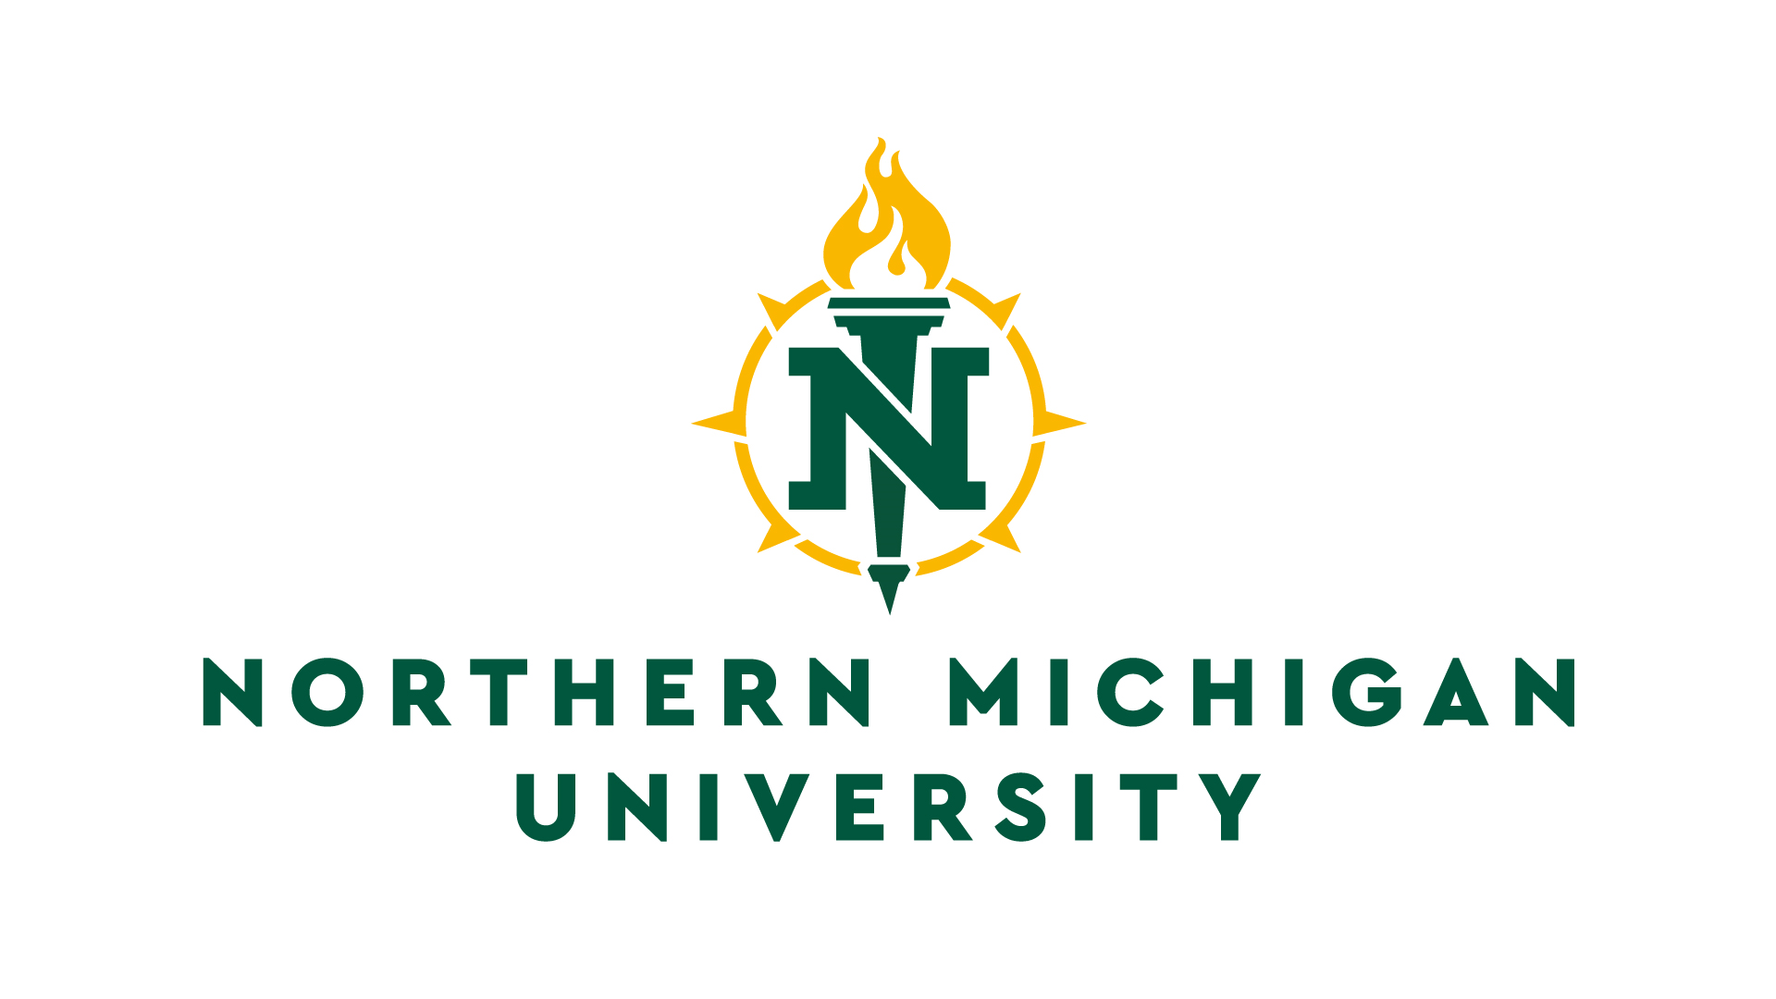
Application for Mass Email Distribution
Graduate Studies & Research

Submission of applications for mass distribution of email, either for intra-institutional or traditional research purposes, will be conducted electronically according to the following procedure:

- For all research email requests to send to a group of NMU faculty, staff, or students, the requesting party will submit the application below to Graduate Studies and Research, via hsrr@nmu.edu.

- For all surveys requiring assistance from NMU’s IR/IT/AIS services for electronic distribution, the investigator must contact the appropriate department after mass email approval has been received. The investigator(s) will work with IT (for generating samples or email list) or CTL (for technology support regarding Qualtrics) and other offices (e.g. the Registrar’s office for policy-related compliances, such as FERPA, etc.) to help with distribution, as needed.

- If the research connected to the mass email qualifies as human subject research, IRB approval must be obtained prior to the mass email application submission.

Application:

- Primary Investigator (must be faculty or staff)
Department
Phone
Email

II. Co-PI(s)
Department
Phone
E-mail

III. Project Title:

IV. IRB Approval Number (if applicable):
*Attach your IRB approval letter

V. Proposed Project Dates: from to

VI. Planned Mass Email Send Date:

VII. Study Population/Email Recipients (check all that apply)

NMU undergraduate students NMU graduate students

NMU full-time faculty NMU adjunct faculty

NMU staff Other (explain)

VIII. Percentage or number of each population in your targeted sample to which you would like the email sent:
*Please make your proposed send population as specific as possible. Note that as a rule, mass emails of more than 20% of NMU’s population will not be approved.

IX. Procedures

A. Describe your subject pool and why you selected them as your survey participants.

B. Describe, in general, what you will be asking the participants to do and how long it will take them. * If sending a survey, include a copy of the survey questions with this application

X. Participant Consent

Will you be asking participants for information that could be used to identify them?
YES /NO

If, yes, include a copy of the informed consent form you will provide to the email recipients. Samples can be found here.

If you will not be asking participants for identifiable information, include a version of this language in your solicitation email:

We are asking you to take this survey because . . . .

If you agree to participate, we would like you to . . .

Your part in this study is anonymous. That means that your answers to all questions are private. No one else can know if you participated in this study and no one else can find out what your answers were. Any reports will be based on group data and will not identify you or any individual as being in this project.

There are no known risks from being in this study, and you will not benefit personally. However, we hope that others may benefit in the future from what we learn as a result of this study.

Completing this survey is completely voluntary. If you decide not to be in this study, or if you stop participating at any time, you won’t be penalized or lose any benefits for which you otherwise qualify.

If you have any further questions regarding your rights as a participant in a research project you may contact Dr. Lisa Eckert of the Human Subjects Research Review Committee of Northern Michigan University (906-227-2300) leckert@nmu.edu. Any questions you have regarding the nature of this research project will be answered by the principal researcher who can be contacted as follows: Dr. XXX (906-227-XXXX) XXXX@nmu.edu.

XI. Confidentiality of Data

Describe who will have access to the data and how you will secure the data.

