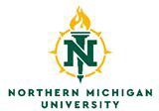

CHILD ASSENT FORM - Ages 7 and under

[customize sections in red to refer to information specific to your study]

Northern Michigan University
DEPARTMENT PROJECT TITLE
IRB APPROVAL NUMBER (when you receive it)

Invitation to Participate:

You and your mom/dad have been asked to help us learn about describe as simply as possible what you are studying. If you decide to do this, you will describe as simply as possible what the child will do. Your parents said that this is okay for you to do. Do you want to do this?

