

**December 2018 / January 2019**

**As 2018 winds down, you might already be thinking about what’s coming up in 2019. Use these tips to help you crush your goals in the New Year!**

.

**The purpose of the “wildcat wellness connection” newsletter is to keep you informed about wellness related issues. Please note that information in this publication, along with other similar materials, is meant to complement the advice of your physician, not replace it. Before making any major changes in your medications, diet or exercise, please consult your physician.**

The following guidelines will help you to set effective and achievable goals:

* **State each goal as a positive statement –**Express your goals positively – "Execute this technique well" is a much better goal than "Don't make this stupid mistake."
* **Be precise –**Set precise goals, with dates and deadlines so that you can measure achievement. You'll know exactly when you have achieved the goal, and can take complete satisfaction from having achieved it.
* **Set priorities –**When you have several goals, give each a priority. This helps you to avoid feeling overwhelmed by having too many goals, and helps to direct your attention to the most important ones.
* **Write goals down –**This helps to keep you focused on your goals and gives you motivation to achieve them.
* **Keep operational goals small –**Keep “stepping stone” goals that you're working towards small and achievable. If a goal is too large, then it can seem that you are not making progress towards it. Keeping goals small and incremental gives more opportunities for reward.
* **Set performance goals, not outcome goals** – You should take care to set goals over which you have as much control as possible. It can be quite dispiriting to fail to achieve a personal goal for reasons beyond your control!

Make sure your goals are SMART

S- Specific

M- Measureable

A- Attainable

R- Relevant

T- Time-bound



Get out and hit the trails this winter!

Northern Michigan University has partnered with the [Noquemanon Trail Network (NTN)](http://www.noquetrails.org/) to provide current NMU students and staff free access to an interconnected, year-round, non-motorized land and water trail system and the ability to check out cross-country skis, snowshoes and fat bikes for daily use.

If you already have equipment, you can start right from campus! The recently constructed [NMU Trailhead](https://goo.gl/maps/NV3KMawYxPT2) connects campus to the North Trails and South Trails of the NTN. This non-motorized trail is intended for mountain bikers, trail runners, hikers, and other outdoor recreation enthusiasts. The on-campus Trailhead serves as a meeting place for everyone from NMU students and employees to Marquette community members. Just follow the signs from the Trailhead to the trails!

Do you prefer downhill skiing? Marquette Mountain’s season passes are still on sale! Check their website for rates. http://shop.marquettemountain.com/

**Winter Fun!**

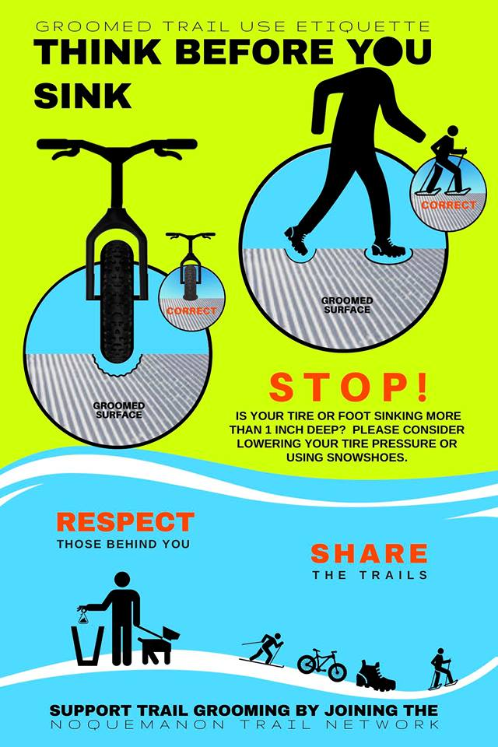

**Be sure to practice proper trail etiquette and be considerate of other trail users.**

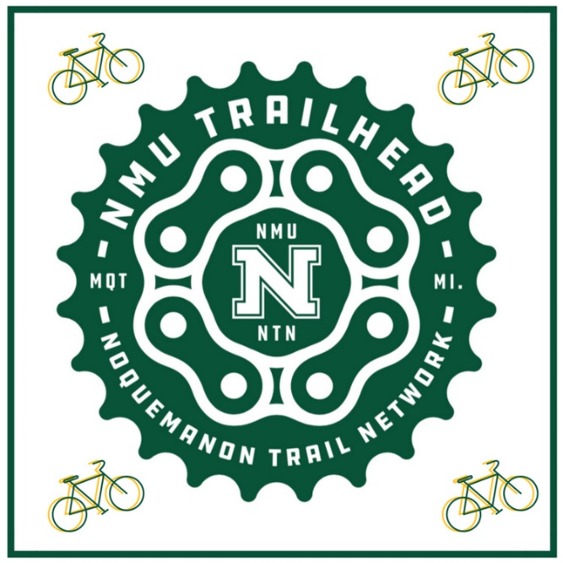

Look for these signs around campus and get your adventure started!



Be sure to stay active over winter break! Check out the Rec Center’s updated Holiday Break schedule!

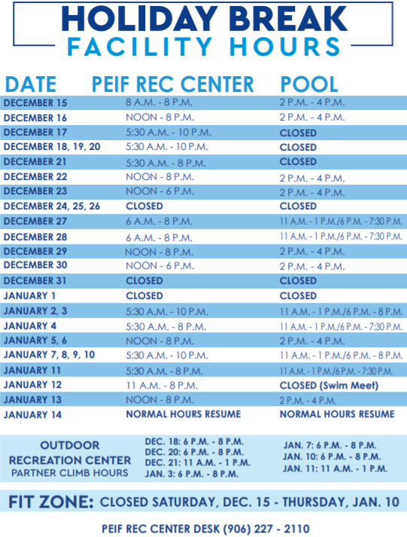

* New Drop In Fitness Classes are being released in January!
* Check back with the Rec Sports Department and get active in a fun way this semester.
* Didn’t get a Rec membership this semester? Now’s the time to sign up for a Mid-year membership at a reduced rate.
* Go to nmu.edu/recsports for more info!

Sources:

NMU (2018).

NTN (2018).

Marquette Mountain (2018).

Mind Tools (2018).